VISVESVARAYA TECHNOLOGICAL UNIVERSITY

“JnanaSangama”, Belgaum -590014, Karnataka.



LAB REPORT

on

OPERATING SYSTEMS

Submitted by VIJETH M D (1WA23CS041)

in partial fulfillment for the award of the degree of

BACHELOR OF ENGINEERING

in

COMPUTER SCIENCE AND ENGINEERING



B.M.S. COLLEGE OF ENGINEERING

(Autonomous Institution under VTU)

BENGALURU-560019

Feb-2025 to June-2025

B. M. S. College of Engineering,

Bull Temple Road, Bangalore 560019

(Affiliated To Visvesvaraya Technological University, Belgaum)

Department of Computer Science and Engineering



CERTIFICATE

This is to certify that the Lab work entitled “OPERATING SYSTEMS – 23CS4PCOPS” carried out by VIJETH M D (1WA23CS041), who is Bonafide student of B. M. S. College of Engineering. It is in partial fulfilment for the award of Bachelor of Engineering in Computer Science and Engineering of the Visvesvaraya Technological University, Belgaum during the year Feb 2025- June 2025. The Lab report has been approved as it satisfies the academic requirements in respect of a

OPERATING SYSTEMS - (23CS4PCOPS) work prescribed for the said degree.

Seema Patil Dr. Kavitha Sooda

Assistant Professor Professor and Head

Department of CSE Department of CSE

BMSCE, Bengaluru BMSCE, Bengaluru

Index Sheet

|  |  |  |
| --- | --- | --- |
| Sl.  No. | Experiment Title | Page No. |
| 1. | Write a C program to simulate the following non-pre-emptive CPU scheduling algorithm to find turnaround time and waiting time.  →FCFS  → SJF (pre-emptive & Non-preemptive) | 1 - 17 |
| 2. | Write a C program to simulate the following CPU scheduling algorithm to find turnaround time and waiting time.  → Priority (pre-emptive & Non-pre-emptive)  →Round Robin (Experiment with different quantum sizes for RR algorithm) | 18 - 40 |
| 3. | Write a C program to simulate multi-level queue scheduling algorithm considering the following scenario. All the processes in the system are divided into two categories – system processes and user processes. System processes are to be given higher priority than user processes. Use FCFS scheduling for the processes in each queue. | 41 - 48 |
| 4. | Write a C program to simulate Real-Time CPU Scheduling algorithms:   1. Rate- Monotonic 2. Earliest-deadline First 3. Proportional scheduling | 49 - 62 |
| 5. | Write a C program to simulate producer-consumer problem using semaphores | 63 - 70 |
| 6. | Write a C program to simulate the concept of Dining Philosophers problem. | 71 - 79 |
| 7. | Write a C program to simulate Bankers algorithm for the purpose of deadlock avoidance. | 80 - 85 |
| 8. | Write a C program to simulate deadlock detection | 86 - 92 |
| 9. | Write a C program to simulate the following contiguous memory allocation techniques a) Worst-fit   1. Best-fit 2. First-fit | 93 - 109 |
| 10. | Write a C program to simulate page replacement algorithms a) | 110 - 124 |

FIFO

|  |  |  |
| --- | --- | --- |
|  | 1. LRU 2. Optimal |  |

Course Outcomes

|  |  |
| --- | --- |
| C01 | Apply the different concepts and functionalities of Operating System |
| C02 | Analyse various Operating system strategies and techniques |
| C03 | Demonstrate the different functionalities of Operating System. |
| C04 | Conduct practical experiments to implement the functionalities of Operating system. |

**Write a C program to simulate the FCFS CPU scheduling algorithm to find turnaround time and waiting time.**

# CODE:

#include <stdio.h> void main()

{

int n;

printf("Enter number of processes: "); scanf("%d", &n);

int AT[n], BT[n], WT[n], TAT[n], CT[n], RT[n];

printf("Enter AT and BT for each process:\n"); for (int i = 0; i < n; i++) {

printf("Enter AT and BT for the process %d: ", i + 1); scanf("%d %d", &AT[i], &BT[i]);

}

int currentTime = 0;

float totalWT = 0, totalTAT = 0; printf("\nProcess\tAT\tBT\tWT\tTAT\tRT\n"); for (int i = 0; i < n; i++) {

if (currentTime < AT[i]) currentTime = AT[i];

CT[i] = currentTime + BT[i]; TAT[i] = CT[i] - AT[i];

WT[i] = TAT[i] - BT[i];

RT[i] = CT[i] - AT[i];

totalWT += WT[i]; totalTAT += TAT[i];

printf("%d\t%d\t%d\t%d\t%d\t\t%d\n", i + 1, AT[i], BT[i], WT[i], TAT[i], RT[i]); currentTime = CT[i];

}

printf("\nAverage Waiting Time: %.2f", totalWT / n); printf("\nAverage Turnaround Time: %.2f\n", totalTAT / n);

}

# OUTPUT:

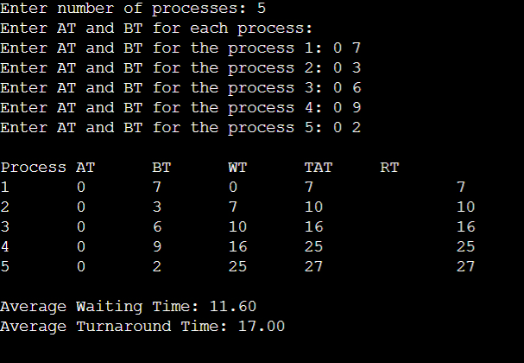

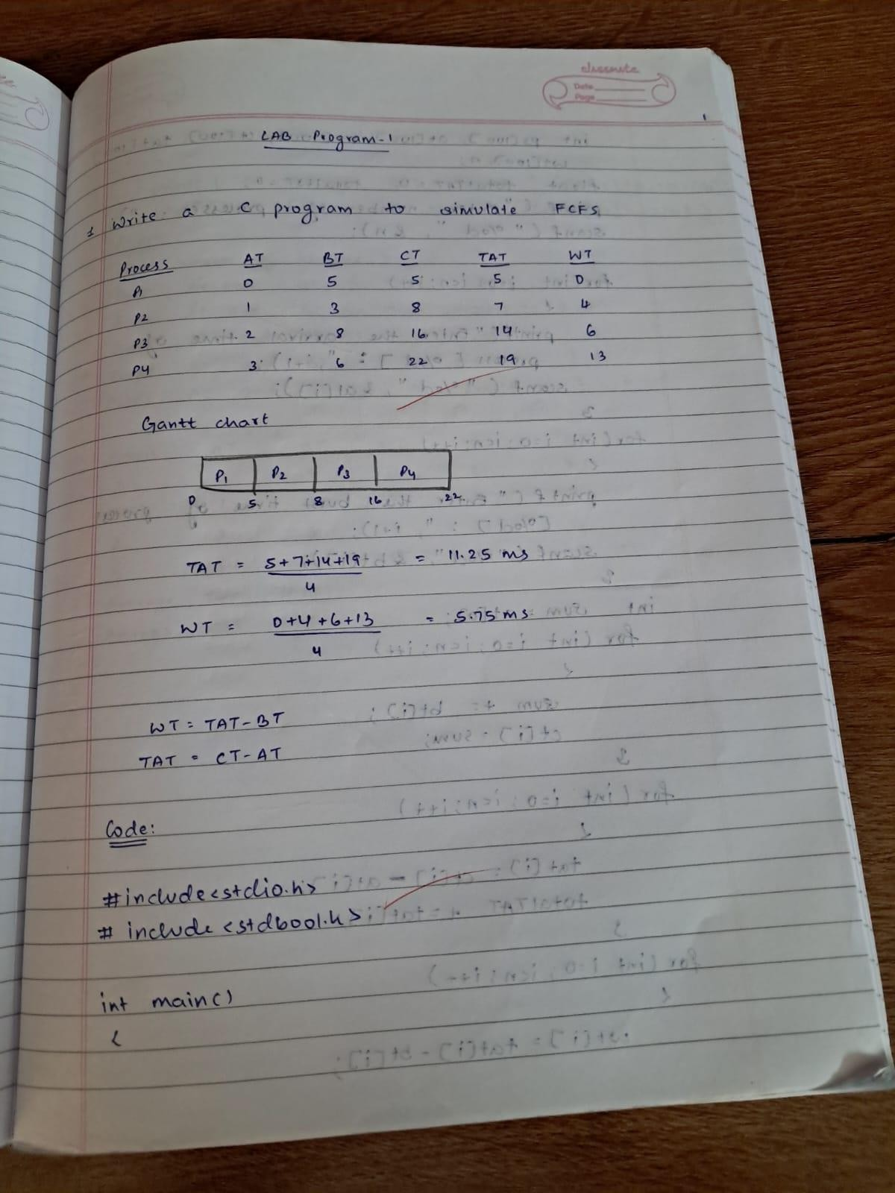

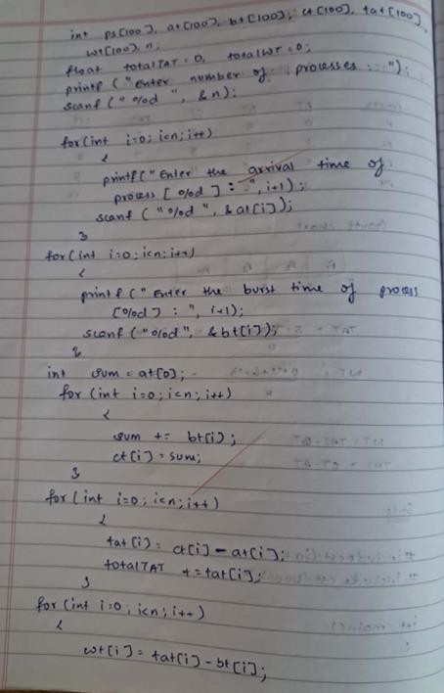

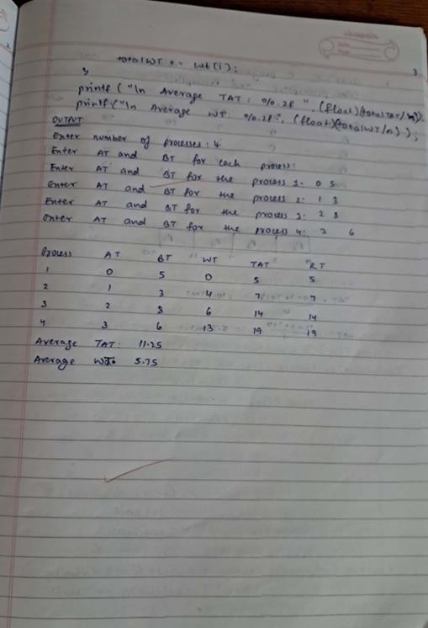

**Write a C program to simulate the SJF CPU scheduling algorithm to find turnaround time and waiting time.(Non Preemptive)**

# CODE:

#include <stdio.h>

void NPSJF(int n, int AT[], int BT[], int CT[], int TAT[], int WT[], int RT[])

{

int completed = 0, time = 0, min_BT, shortest, finish_time; int remaining_BT[n];

for (int i = 0; i < n; i++)

{

remaining_BT[i] = BT[i];

}

while (completed < n)

{

min_BT = 9999;

shortest = -1;

for (int i = 0; i < n; i++)

{

if (AT[i] <= time && remaining_BT[i] > 0 && BT[i] < min_BT)

{

min_BT = BT[i]; shortest = i;

}

}

if (shortest == -1)

{

time++; continue;

}

time += BT[shortest]; remaining_BT[shortest] = 0; completed++;

CT[shortest] = time;

TAT[shortest] = CT[shortest] - AT[shortest]; WT[shortest] = TAT[shortest] - BT[shortest]; RT[shortest] = WT[shortest];

}

}

void display(int n, int AT[], int BT[], int CT[], int TAT[], int WT[], int RT[])

{

printf("\nProcess\tAT\tBT\tCT\tTAT\tWT\tRT\n"); for (int i = 0; i < n; i++)

{

printf("%d\t%d\t%d\t%d\t%d\t%d\t%d\n", i + 1, AT[i], BT[i], CT[i], TAT[i], WT[i], RT[i]);

}

}

int main()

{

int n;

printf("Enter number of processes: "); scanf("%d", &n);

int AT[n], BT[n], CT[n], TAT[n], WT[n], RT[n];

printf("Enter Arrival Time and Burst Time for each process:\n"); for (int i = 0; i < n; i++)

{

printf("Enter process %d AT: ", i + 1); scanf("%d", &AT[i]);

printf("Enter process %d BT: ", i + 1); scanf("%d", &BT[i]);

}

NPSJF(n, AT, BT, CT, TAT, WT, RT); display(n, AT, BT, CT, TAT, WT, RT);

return 0;

}

# OUTPUT:

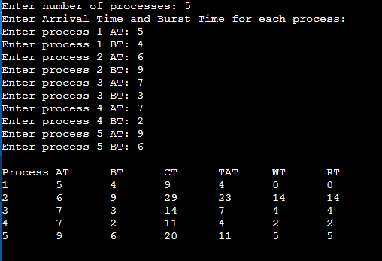

**Write a C program to simulate the SJF CPU scheduling algorithm to find turnaround time and waiting time.(Preemptive)**

# CODE:

#include <stdio.h>

void preemptiveSJF(int n, int AT[], int BT[], int CT[], int TAT[], int WT[], int RT[])

{

int remaining_BT[n];

int completed = 0, time = 0, min_BT, shortest; int flag[n];

for (int i = 0; i < n; i++)

{

remaining_BT[i] = BT[i]; flag[i] = 0;

}

while (completed < n)

{

min_BT = 9999;

shortest = -1;

for (int i = 0; i < n; i++)

{

if (AT[i] <= time && remaining_BT[i] > 0 && remaining_BT[i] < min_BT && flag[i] == 0)

{

min_BT = remaining_BT[i]; shortest = i;

}

}

if (shortest == -1)

{

time++;

continue;

}

remaining_BT[shortest]--;

if (remaining_BT[shortest] == 0)

{

completed++; flag[shortest] = 1; CT[shortest] = time + 1;

TAT[shortest] = CT[shortest] - AT[shortest]; WT[shortest] = TAT[shortest] - BT[shortest]; RT[shortest] = WT[shortest];

}

time++;

}

}

void display(int n, int AT[], int BT[], int CT[], int TAT[], int WT[], int RT[])

{

printf("\nProcess\tAT\tBT\tCT\tTAT\tWT\tRT\n"); for (int i = 0; i < n; i++)

{

printf("%d\t%d\t%d\t%d\t%d\t%d\t%d\n", i + 1, AT[i], BT[i], CT[i], TAT[i], WT[i], RT[i]);

}

}

int main()

{

int n;

printf("Enter number of processes: "); scanf("%d", &n);

int AT[n], BT[n], CT[n], TAT[n], WT[n], RT[n];

printf("Enter Arrival Time and Burst Time for each process:\n"); for (int i = 0; i < n; i++)

{

printf("Enter process %d Arrival Time: ", i + 1); scanf("%d", &AT[i]);

printf("Enter process %d Burst Time: ", i + 1); scanf("%d", &BT[i]);

}

preemptiveSJF(n, AT, BT, CT, TAT, WT, RT); display(n, AT, BT, CT, TAT, WT, RT);

return 0;

}

# OUTPUT:

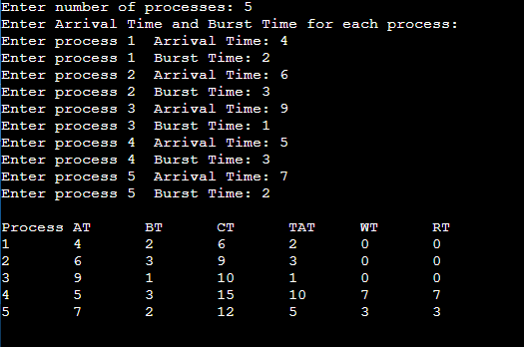

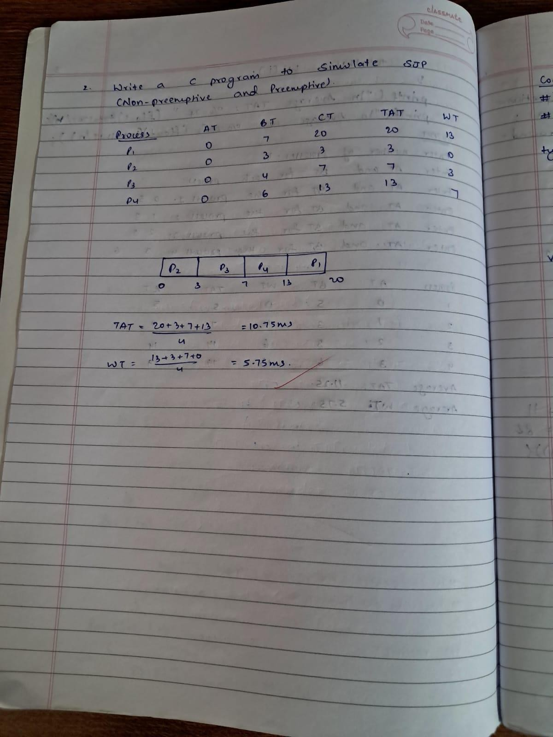

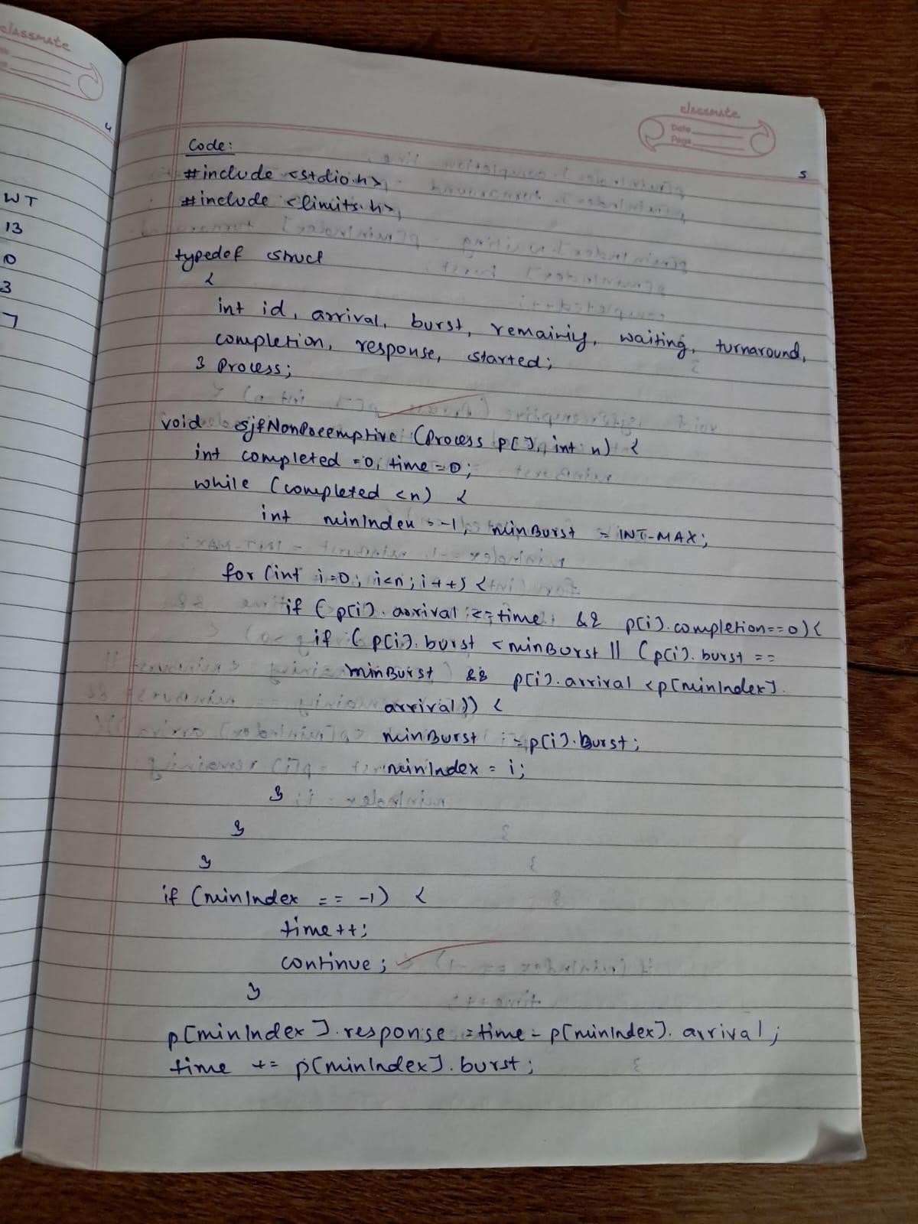

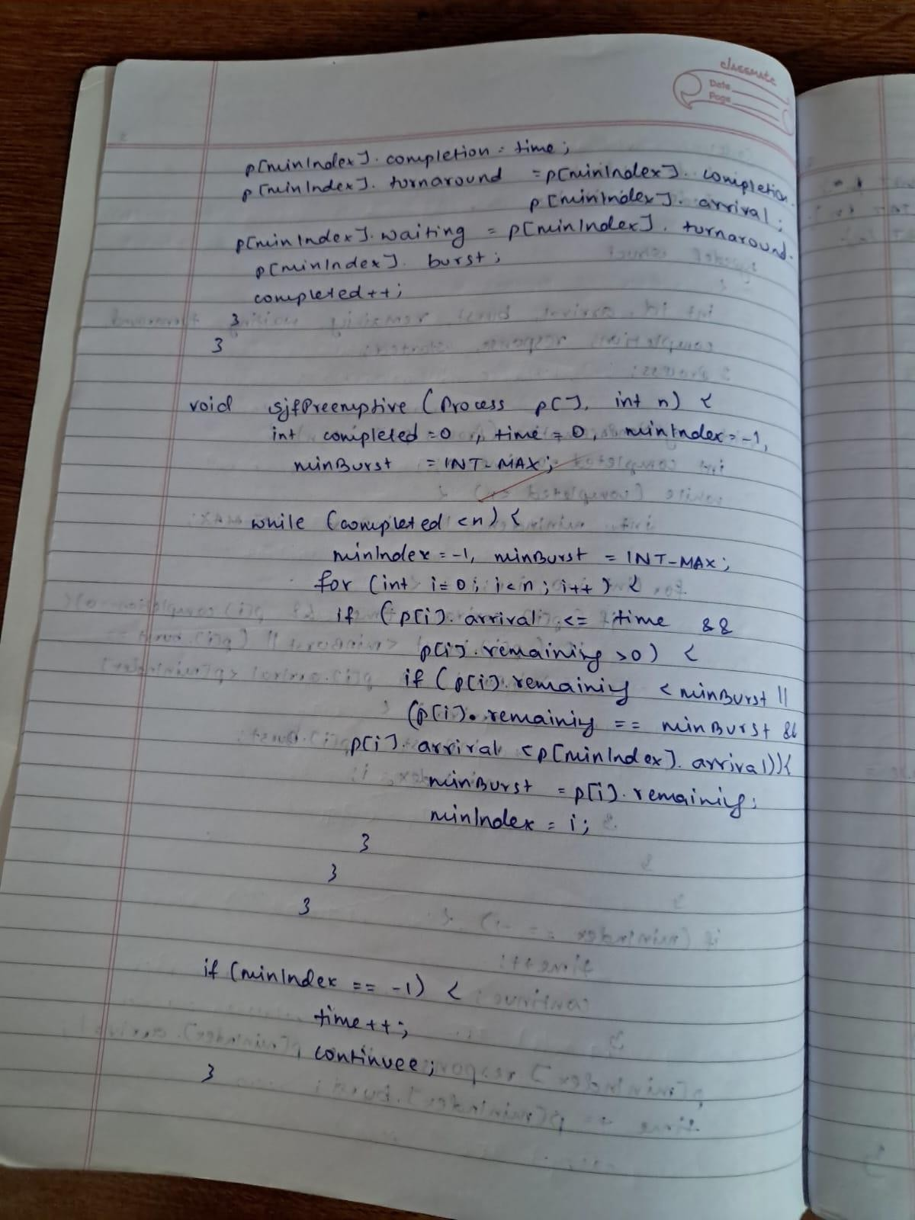

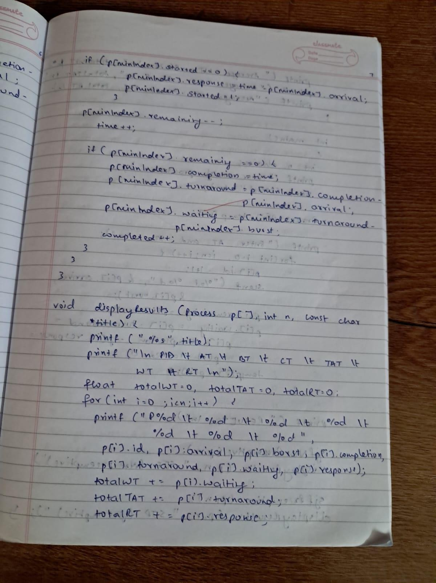

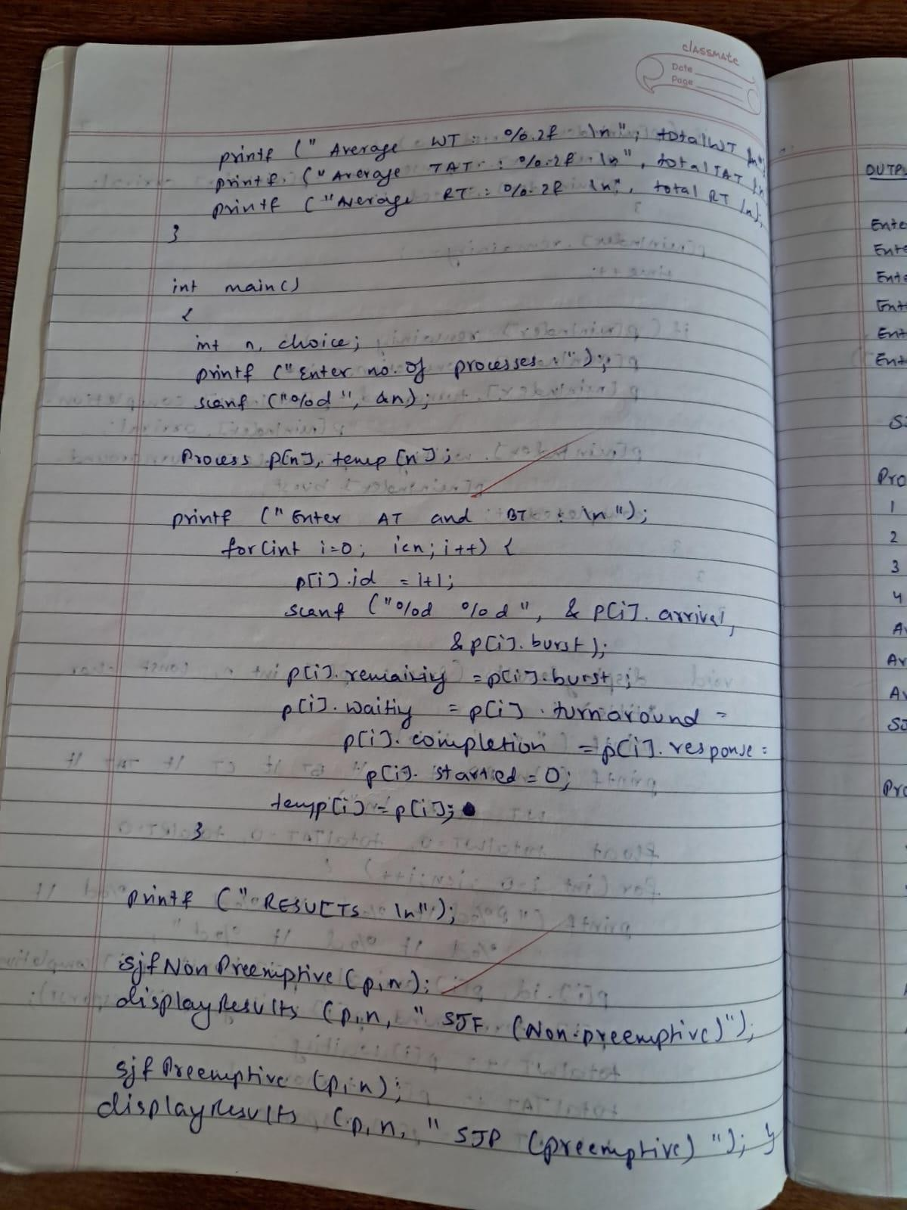

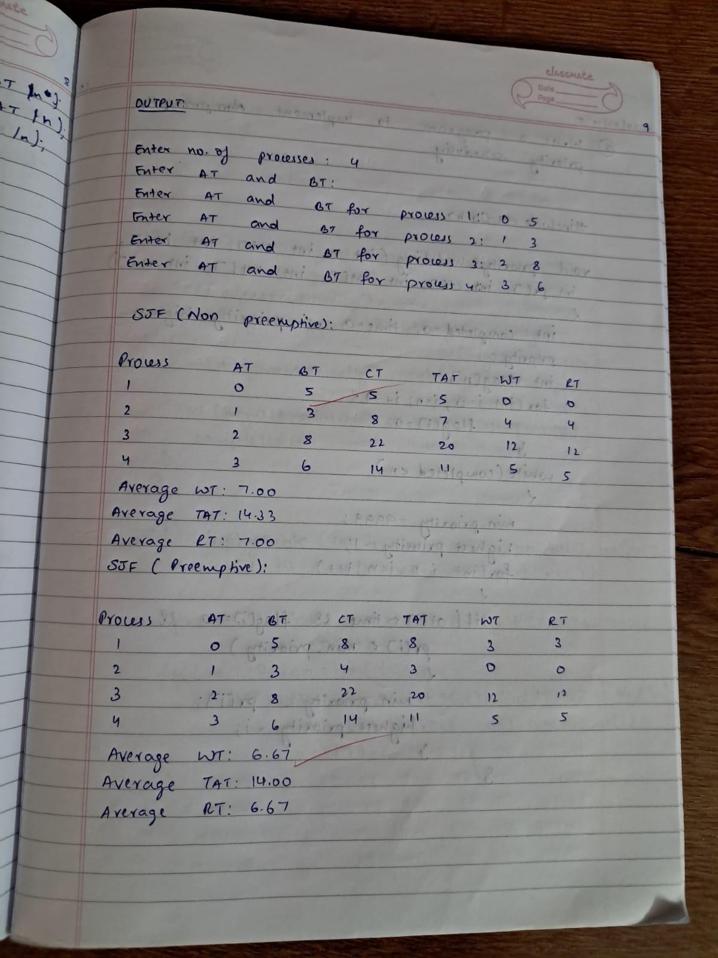

**Write a C program to simulate the following CPU scheduling algorithm to find turnaround time and waiting time. PRIORITY (Non Preemptive)**

# CODE:

#include <stdio.h>

void priorityScheduling(int n, int at[], int bt[], int pr[], int ct[], int tat[], int wt[], int rt[]) { int completed = 0, time = 0, min_priority, highest_priority;

int flag[n];

for (int i = 0; i < n; i++) { flag[i] = 0;

}

while (completed < n) { min_priority = 9999;

highest_priority = -1;

for (int i = 0; i < n; i++) {

if (at[i] <= time && flag[i] == 0 && pr[i] < min_priority) { min_priority = pr[i];

highest_priority = i;

}

}

if (highest_priority == -1) { time++;

continue;

}

time += bt[highest_priority]; flag[highest_priority] = 1; ct[highest_priority] = time;

tat[highest_priority] = ct[highest_priority] - at[highest_priority]; wt[highest_priority] = tat[highest_priority] - bt[highest_priority]; rt[highest_priority] = wt[highest_priority];

completed++;

}

}

void displayTable(int n, int at[], int bt[], int pr[], int ct[], int tat[], int wt[], int rt[]) { printf("\nProcess\tAT\tBT\tPriority\tCT\tTAT\tWT\tRT\n");

for (int i = 0; i < n; i++) {

printf("%d\t%d\t%d\t%d\t\t%d\t%d\t%d\t%d\n", i + 1, at[i], bt[i], pr[i], ct[i], tat[i], wt[i], rt[i]);

}

}

int main() { int n;

printf("Enter number of processes: "); scanf("%d", &n);

int at[n], bt[n], pr[n], ct[n], tat[n], wt[n], rt[n];

printf("Enter Arrival Time, Burst Time, and Priority for each process:\n"); for (int i = 0; i < n; i++) {

printf("Process %d - Arrival Time: ", i + 1); scanf("%d", &at[i]);

printf("Process %d - Burst Time: ", i + 1); scanf("%d", &bt[i]);

printf("Process %d - Priority: ", i + 1); scanf("%d", &pr[i]);

}

priorityScheduling(n, at, bt, pr, ct, tat, wt, rt); displayTable(n, at, bt, pr, ct, tat, wt, rt);

return 0;

}

# OUTPUT:

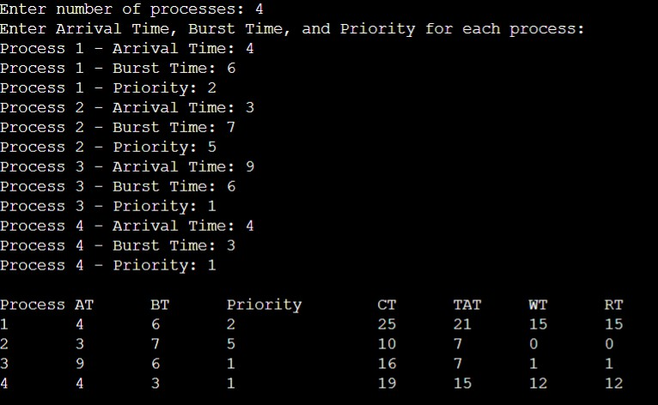

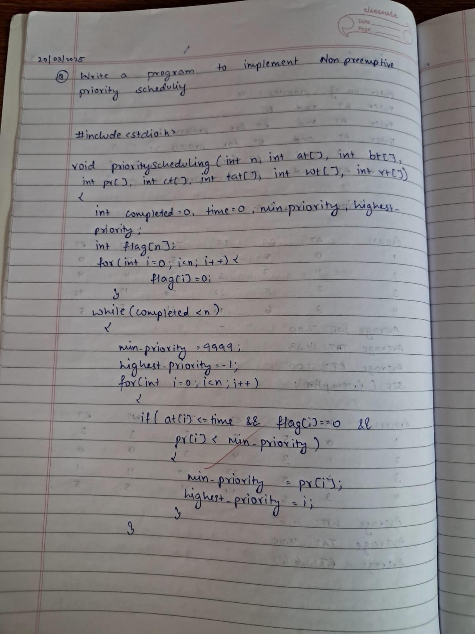

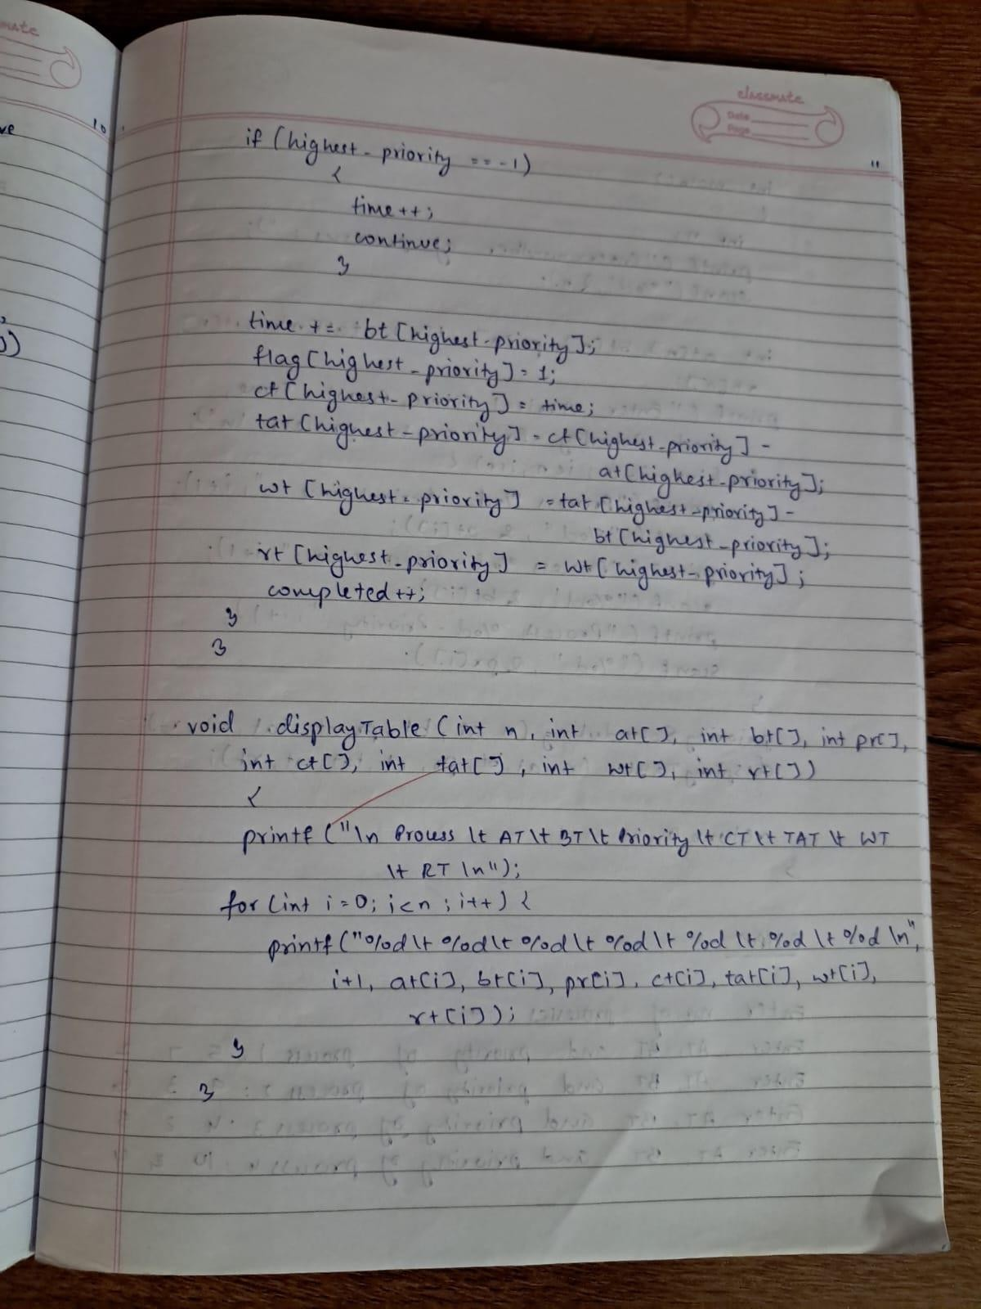

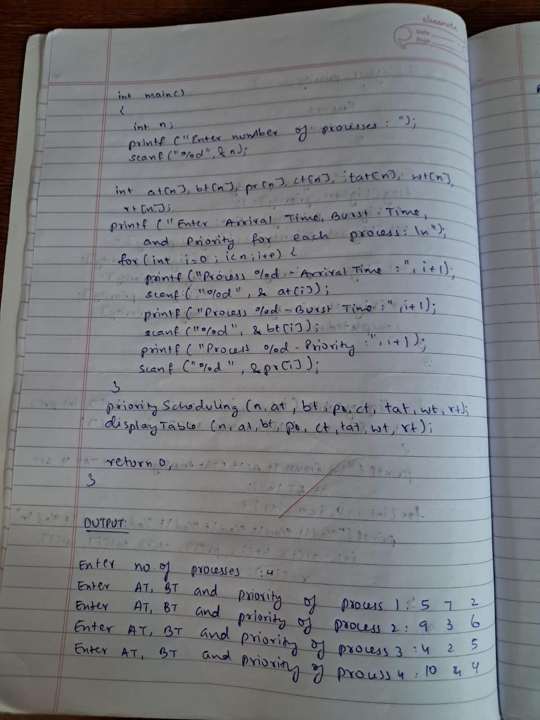

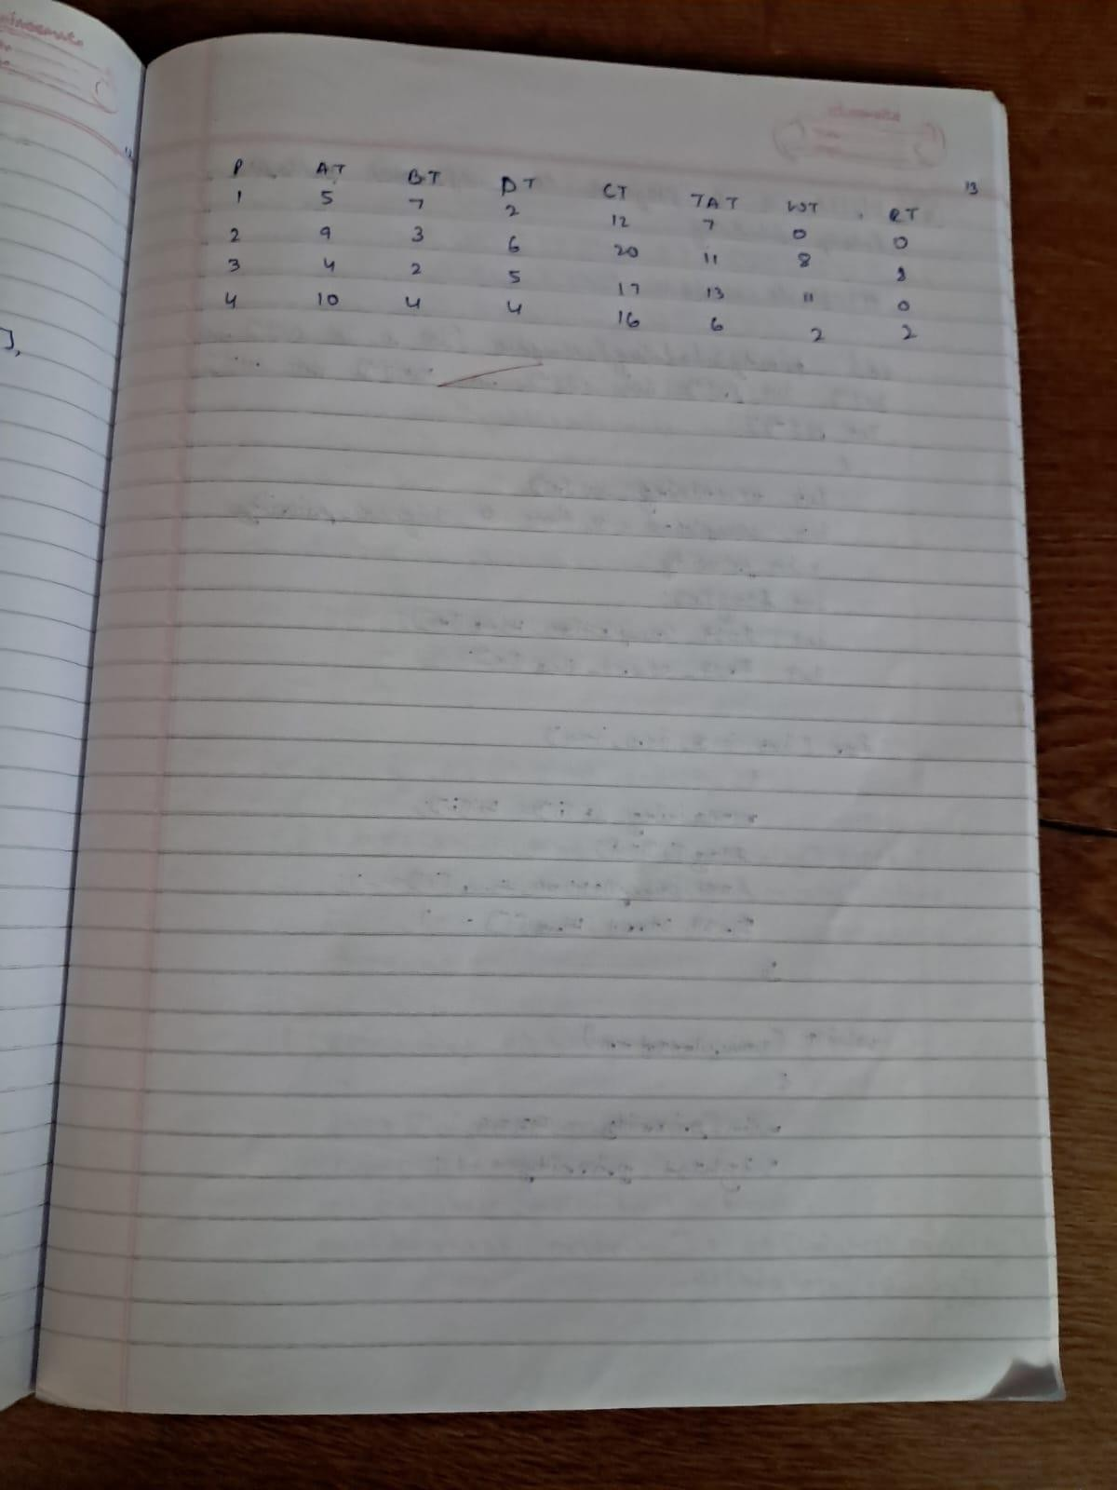

**Write a C program to simulate the following CPU scheduling algorithm to find turnaround time and waiting time. PRIORIITY (Preemptive)**

# CODE:

#include <stdio.h>

void prioritySchedulingPreemptive(int n, int at[], int bt[], int pr[], int ct[], int tat[], int wt[], int rt[]) {

int remaining_bt[n];

int completed = 0, time = 0, highest_priority, min_priority; int flag[n];

int last_completion_time[n]; int first_start_time[n];

for (int i = 0; i < n; i++) { remaining_bt[i] = bt[i]; flag[i] = 0;

last_completion_time[i] = -1;

first_start_time[i] = -1;

}

while (completed < n) { min_priority = 9999;

highest_priority = -1;

for (int i = 0; i < n; i++) {

if (at[i] <= time && flag[i] == 0 && pr[i] < min_priority && remaining_bt[i] > 0) { min_priority = pr[i];

highest_priority = i;

}

}

if (highest_priority == -1) { time++;

continue;

}

remaining_bt[highest_priority]--;

if (first_start_time[highest_priority] == -1) { first_start_time[highest_priority] = time;

}

time++;

if (remaining_bt[highest_priority] == 0) {

flag[highest_priority] = 1; completed++; ct[highest_priority] = time;

tat[highest_priority] = ct[highest_priority] - at[highest_priority]; wt[highest_priority] = tat[highest_priority] - bt[highest_priority]; rt[highest_priority] = first_start_time[highest_priority] - at[highest_priority];

}

}

}

void displayTable(int n, int at[], int bt[], int pr[], int ct[], int tat[], int wt[], int rt[]) { printf("\nP\tAT\tBT\tPt\tCT\tTAT\tWT\tRT\n");

for (int i = 0; i < n; i++) {

printf("%d\t%d\t%d\t%d\t%d\t%d\t%d\t%d\n", i + 1, at[i], bt[i], pr[i], ct[i], tat[i], wt[i], rt[i]);

}

}

int main() { int n;

printf("Enter number of processes: "); scanf("%d", &n);

int at[n], bt[n], pr[n], ct[n], tat[n], wt[n], rt[n];

printf("Enter Arrival Time, Burst Time, and Priority for each process:\n"); for (int i = 0; i < n; i++) {

printf("Process %d - Arrival Time: ", i + 1); scanf("%d", &at[i]);

printf("Process %d - Burst Time: ", i + 1); scanf("%d", &bt[i]);

printf("Process %d - Priority: ", i + 1); scanf("%d", &pr[i]);

}

prioritySchedulingPreemptive(n, at, bt, pr, ct, tat, wt, rt); displayTable(n, at, bt, pr, ct, tat, wt, rt);

return 0;

}

# OUTPUT:

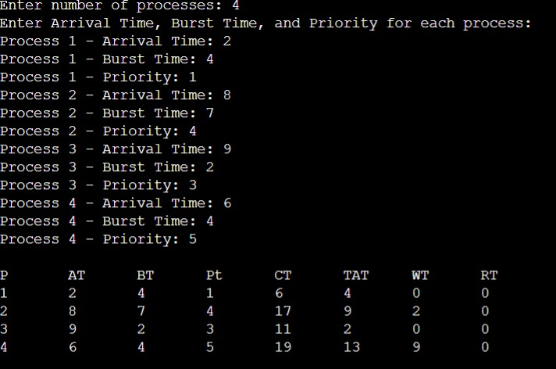

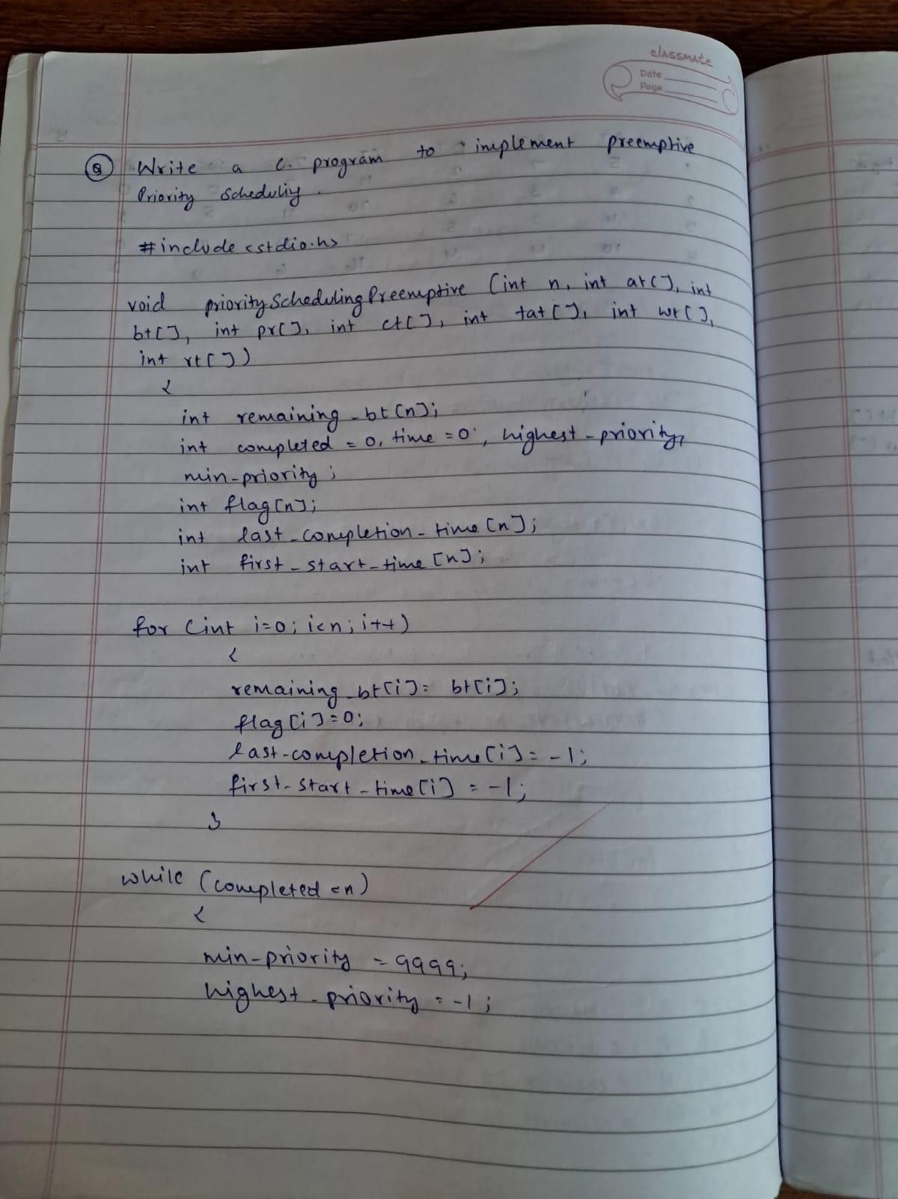

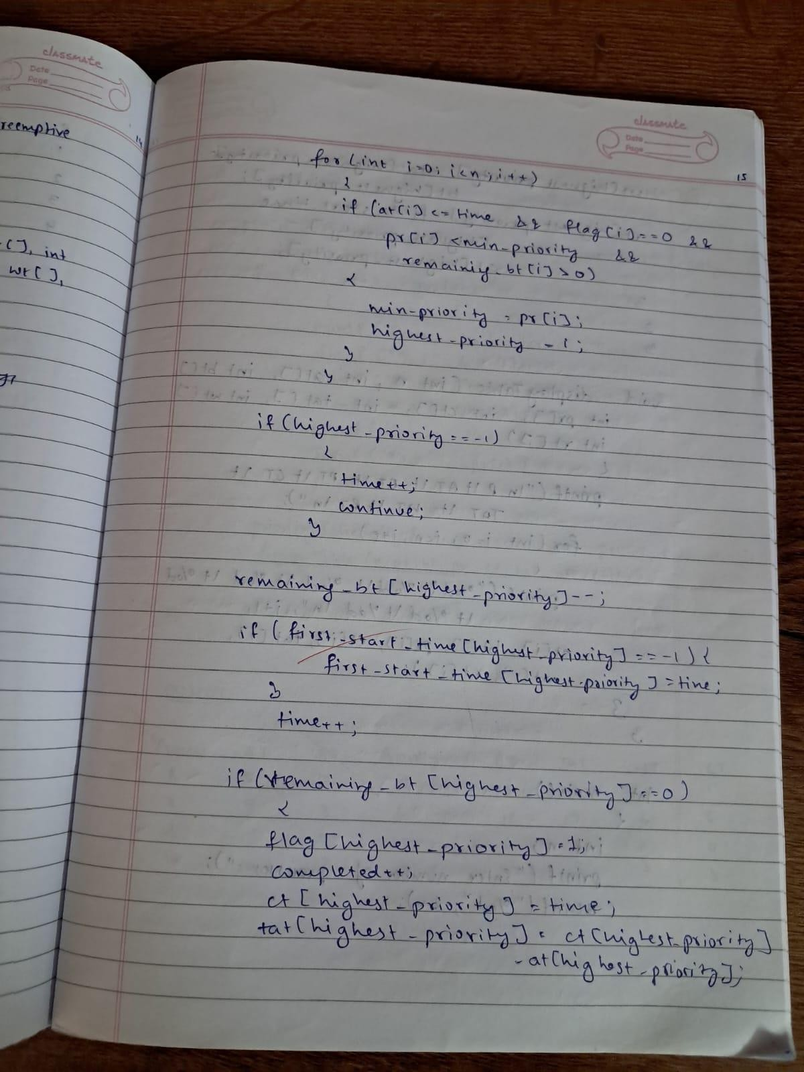

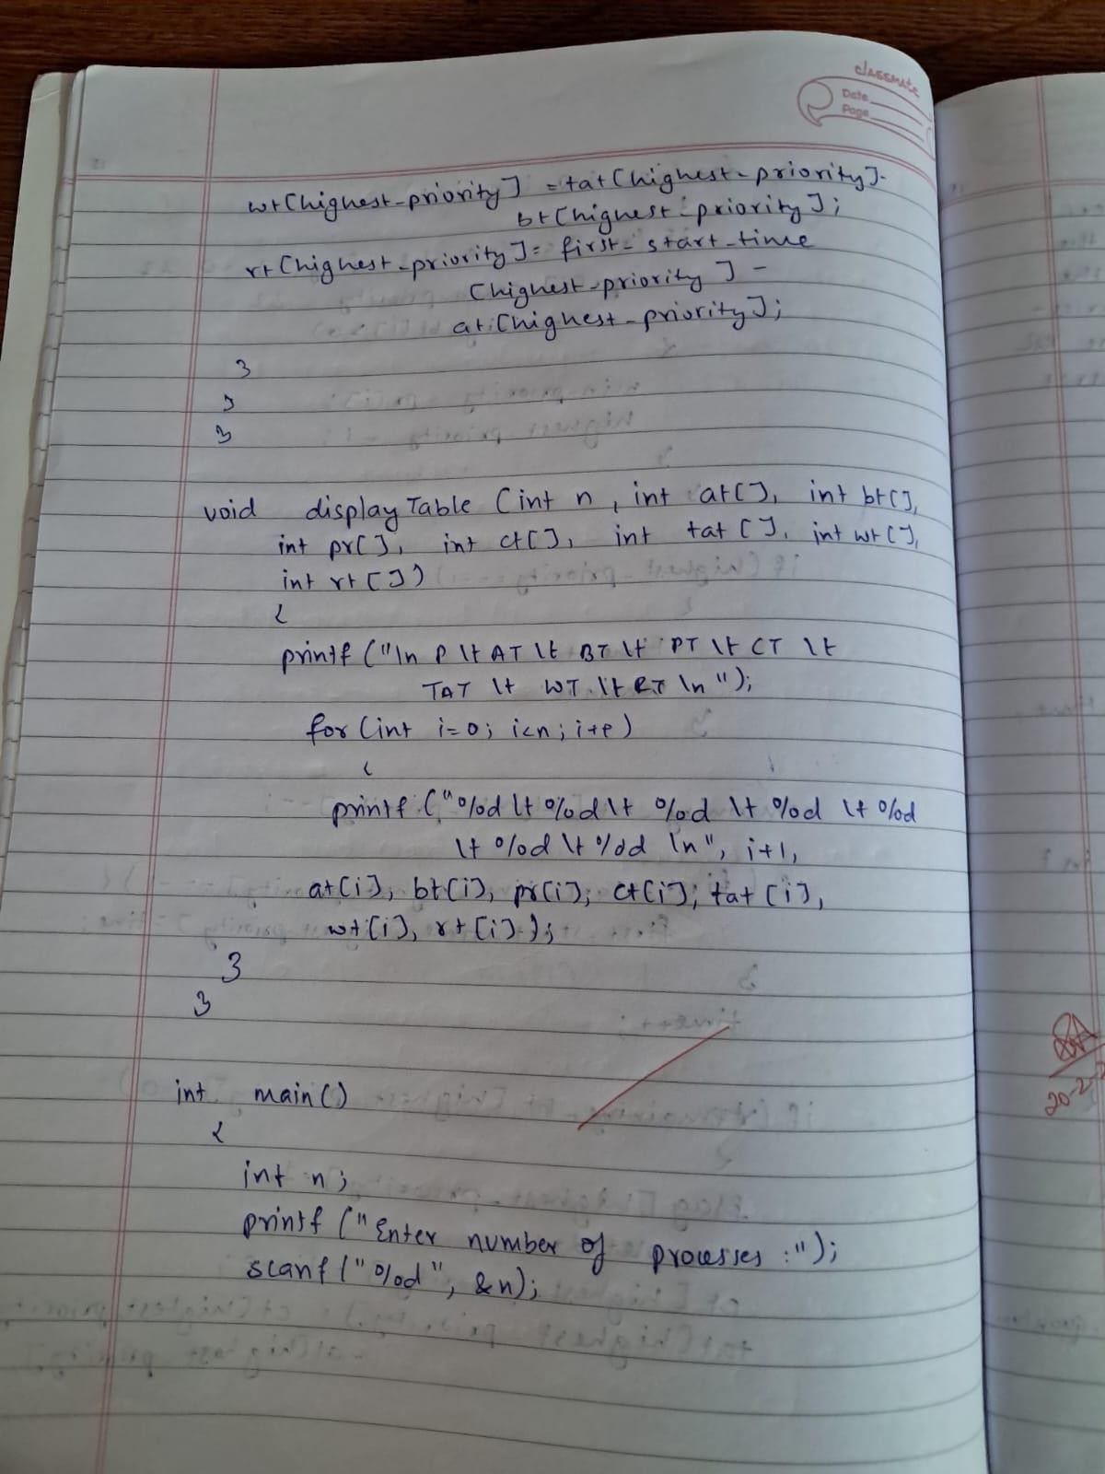

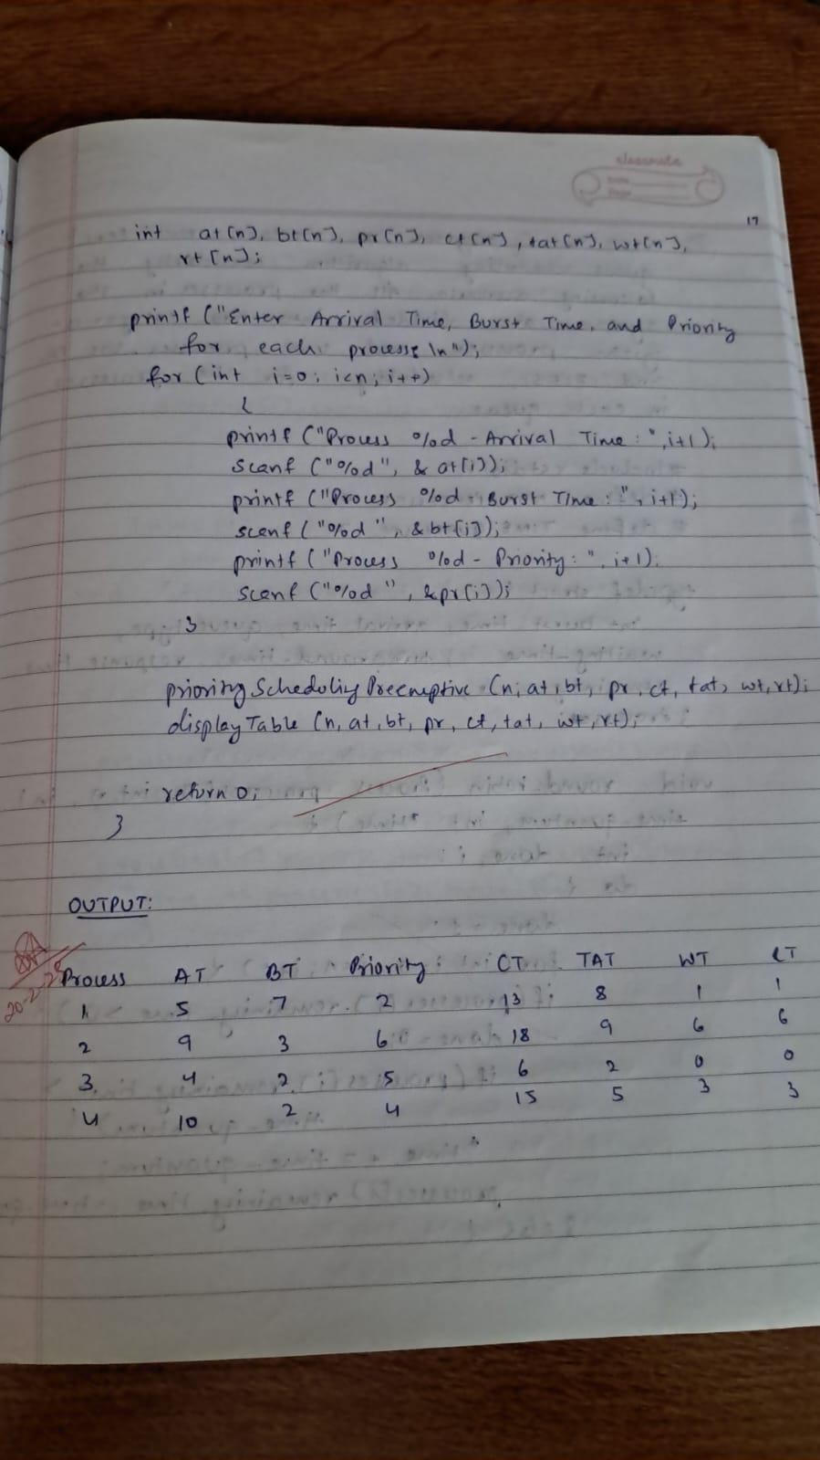

**Write a C program to simulate the Round Robin CPU scheduling algorithm to find turnaround time and waiting time.**

# CODE:

#include <stdio.h>

void findTurnaroundTime(int processes[], int n, int bt[], int wt[], int tat[]) { for (int i = 0; i < n; i++) {

tat[i] = bt[i] + wt[i];

}

}

void findWaitingTime(int processes[], int n, int bt[], int wt[], int quantum) { int remaining_bt[n];

for (int i = 0; i < n; i++) { remaining_bt[i] = bt[i];

}

int time = 0; while (1) {

int done = 1;

for (int i = 0; i < n; i++) {

if (remaining_bt[i] > 0) { done = 0;

if (remaining_bt[i] > quantum) { time += quantum; remaining_bt[i] -= quantum;

} else {

time += remaining_bt[i]; wt[i] = time - bt[i]; remaining_bt[i] = 0;

}

}

}

if (done == 1) break;

}

}

void roundRobin(int processes[], int n, int bt[], int quantum) { int wt[n], tat[n];

for (int i = 0; i < n; i++) { wt[i] = 0;

}

findWaitingTime(processes, n, bt, wt, quantum); findTurnaroundTime(processes, n, bt, wt, tat);

int total_wt = 0, total_tat = 0;

printf("\nProcess\tBurst Time\tWaiting Time\tTurnaround Time\n"); for (int i = 0; i < n; i++) {

total_wt += wt[i]; total_tat += tat[i];

printf("P%d\t%d\t\t%d\t\t%d\n", processes[i], bt[i], wt[i], tat[i]);

}

printf("\nAverage Waiting Time: %.2f", (float)total_wt / n); printf("\nAverage Turnaround Time: %.2f", (float)total_tat / n);

}

int main() {

int n, quantum;

printf("Enter the number of processes: "); scanf("%d", &n);

int processes[n], bt[n];

printf("Enter the burst time for each process:\n"); for (int i = 0; i < n; i++) {

printf("Process %d burst time: ", i + 1); scanf("%d", &bt[i]);

processes[i] = i + 1;

}

printf("Enter the time quantum: "); scanf("%d", &quantum);

roundRobin(processes, n, bt, quantum);

return 0;

}

# OUTPUT:

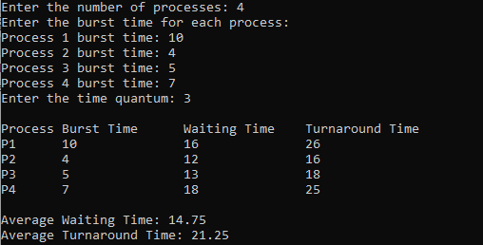

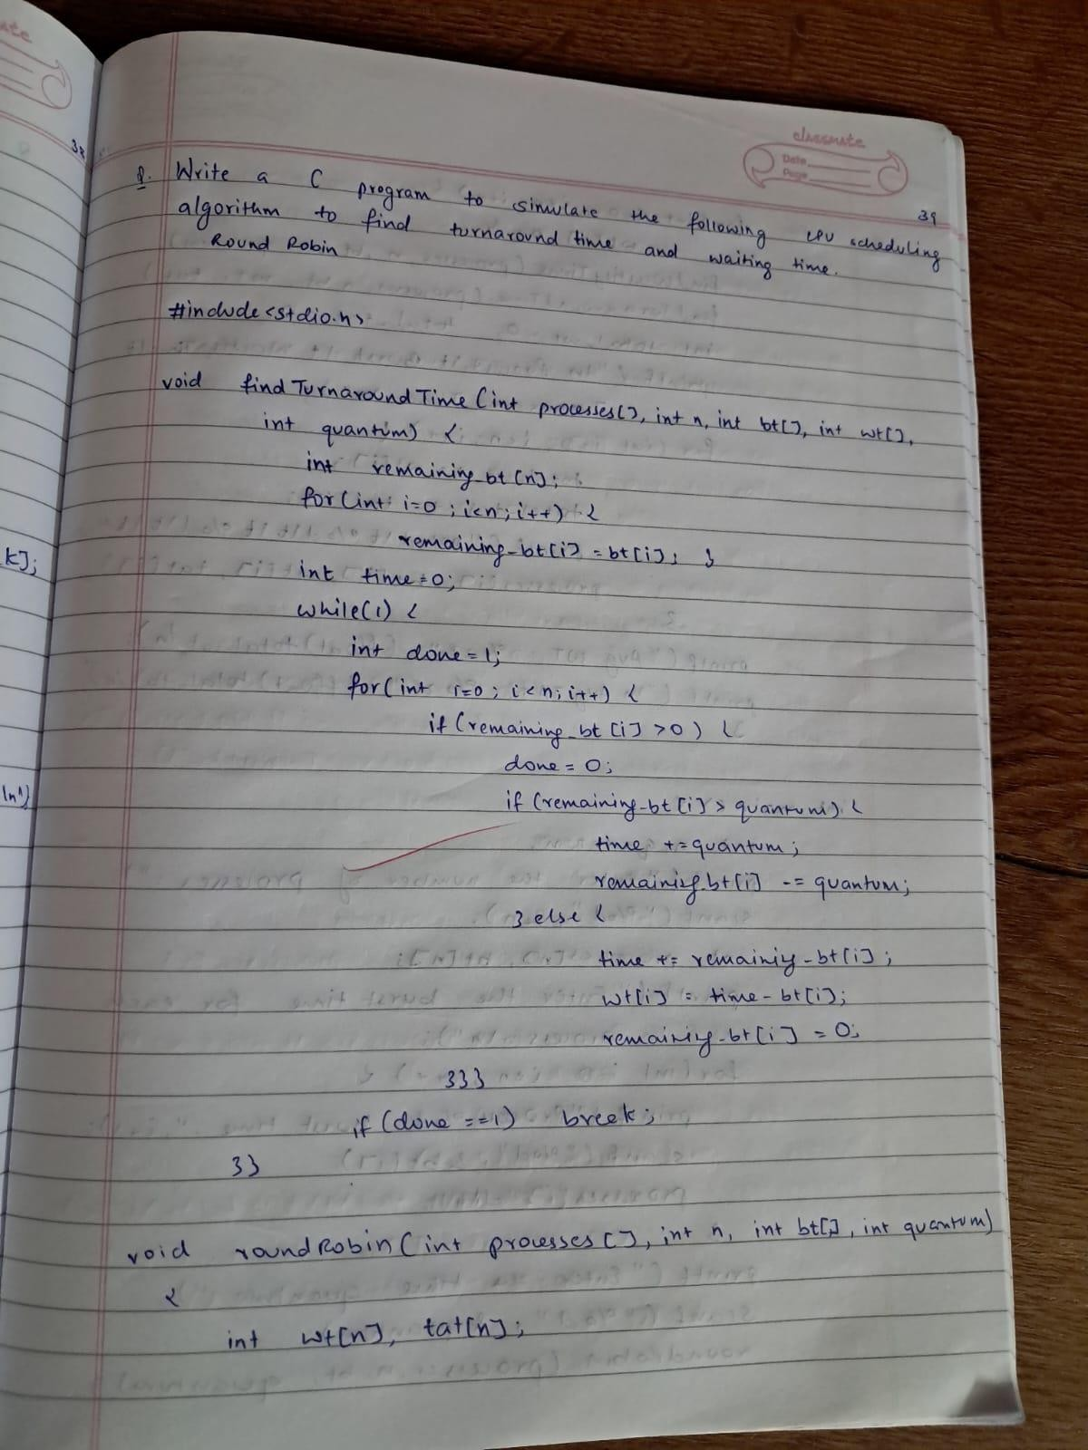

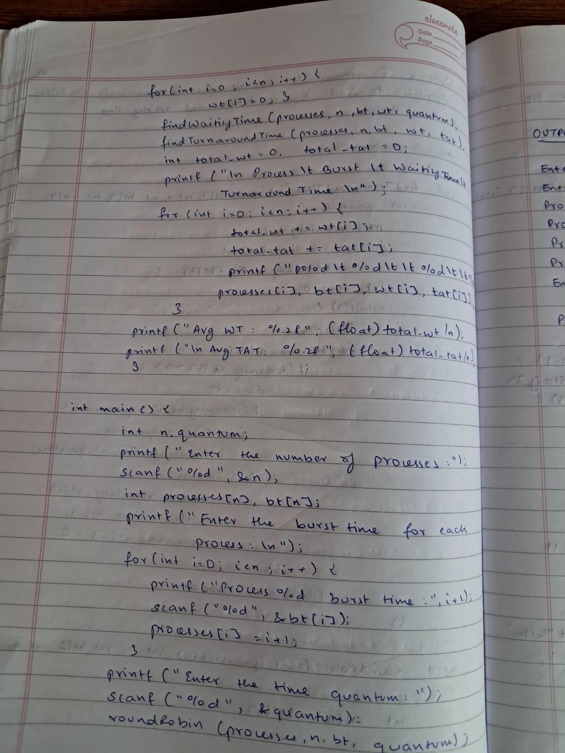

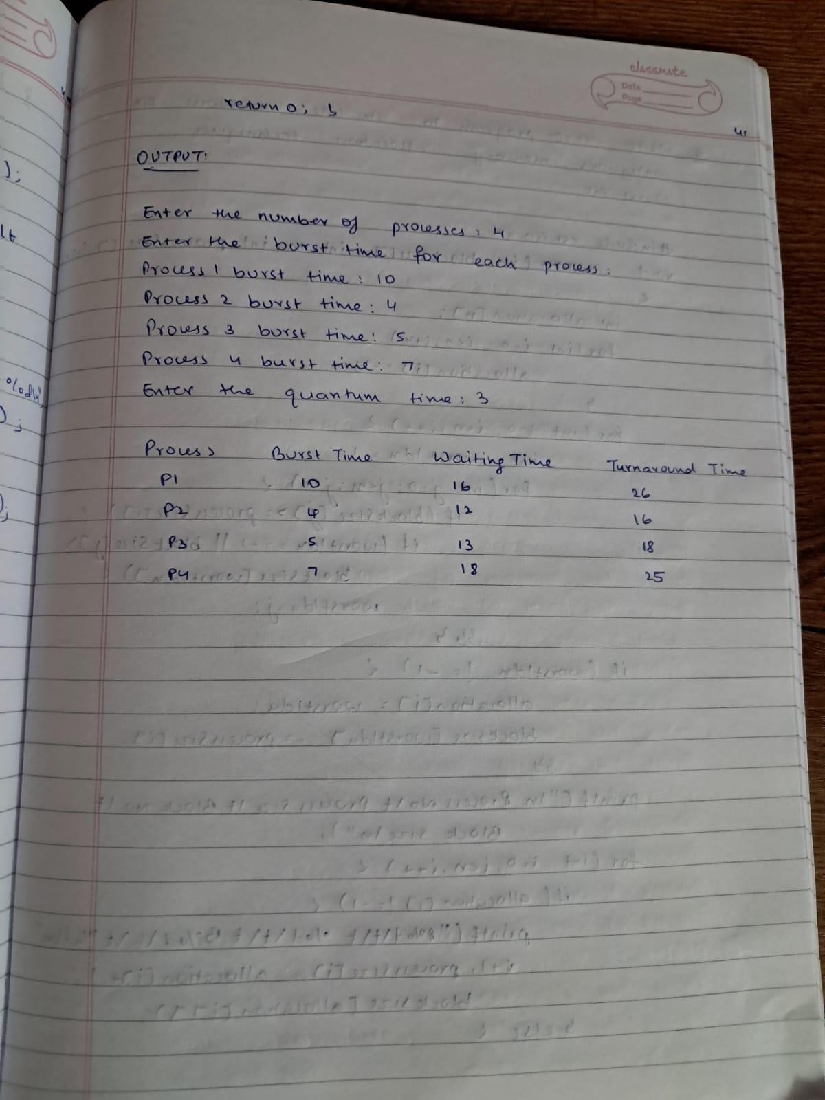

**Write a C program to simulate multi-level queue scheduling algorithm considering the following scenario. All the processes in the system are divided into two categories – system processes and user processes. System processes are to be given higher priority than user processes. Use FCFS scheduling for the processes in each queue.**

# CODE:

#include <stdio.h>

#define MAX_PROCESSES 10

#define TIME_QUANTUM 2

typedef struct {

int burst_time, arrival_time, queue_type, waiting_time, turnaround_time, response_time, remaining_time;

} Process;

void round_robin(Process processes[], int n, int time_quantum, int *time) { int done, i;

do {

done = 1;

for (i = 0; i < n; i++) {

if (processes[i].remaining_time > 0) { done = 0;

if (processes[i].remaining_time > time_quantum) {

*time += time_quantum; processes[i].remaining_time -= time_quantum;

} else {

*time += processes[i].remaining_time; processes[i].waiting_time = *time - processes[i].arrival_time -

processes[i].burst_time;

processes[i].turnaround_time = *time - processes[i].arrival_time; processes[i].response_time = processes[i].waiting_time; processes[i].remaining_time = 0;

}

}

}

} while (!done);

}

void fcfs(Process processes[], int n, int *time) { for (int i = 0; i < n; i++) {

if (*time < processes[i].arrival_time) {

*time = processes[i].arrival_time;

}

processes[i].waiting_time = *time - processes[i].arrival_time; processes[i].turnaround_time = processes[i].waiting_time + processes[i].burst_time; processes[i].response_time = processes[i].waiting_time;

*time += processes[i].burst_time;

}

}

int main() {

Process processes[MAX_PROCESSES], system_queue[MAX_PROCESSES], user_queue[MAX_PROCESSES];

int n, sys_count = 0, user_count = 0, time = 0;

float avg_waiting = 0, avg_turnaround = 0, avg_response = 0, throughput;

printf("Enter number of processes: "); scanf("%d", &n);

for (int i = 0; i < n; i++) {

printf("Enter Burst Time, Arrival Time and Queue of P%d: ", i + 1); scanf("%d %d %d", &processes[i].burst_time, &processes[i].arrival_time,

&processes[i].queue_type);

processes[i].remaining_time = processes[i].burst_time;

if (processes[i].queue_type == 1) { system_queue[sys_count++] = processes[i];

} else {

user_queue[user_count++] = processes[i];

}

}

// Sort user processes by arrival time for FCFS for (int i = 0; i < user_count - 1; i++) {

for (int j = 0; j < user_count - i - 1; j++) {

if (user_queue[j].arrival_time > user_queue[j + 1].arrival_time) { Process temp = user_queue[j];

user_queue[j] = user_queue[j + 1]; user_queue[j + 1] = temp;

}

}

}

printf("\nQueue 1 is System Process\nQueue 2 is User Process\n"); round_robin(system_queue, sys_count, TIME_QUANTUM, &time); fcfs(user_queue, user_count, &time);

printf("\nProcess Waiting Time Turn Around Time Response Time\n");

for (int i = 0; i < sys_count; i++) {

avg_waiting += system_queue[i].waiting_time; avg_turnaround += system_queue[i].turnaround_time; avg_response += system_queue[i].response_time;

printf("%d %d %d %d\n", i + 1, system_queue[i].waiting_time, system_queue[i].turnaround_time, system_queue[i].response_time);

}

for (int i = 0; i < user_count; i++) { avg_waiting += user_queue[i].waiting_time;

avg_turnaround += user_queue[i].turnaround_time; avg_response += user_queue[i].response_time;

printf("%d %d %d %d\n", i + 1 + sys_count, user_queue[i].waiting_time, user_queue[i].turnaround_time, user_queue[i].response_time);

}

avg_waiting /= n; avg_turnaround /= n; avg_response /= n; throughput = (float)n / time;

printf("\nAverage Waiting Time: %.2f", avg_waiting); printf("\nAverage Turn Around Time: %.2f", avg_turnaround); printf("\nAverage Response Time: %.2f", avg_response); printf("\nThroughput: %.2f", throughput);

printf("\nProcess returned %d (0x%d) execution time: %.3f s\n", time, time, (float)time);

return 0;

}

# OUTPUT:

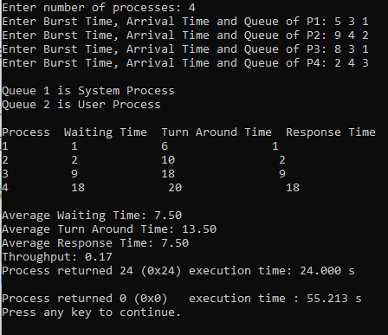

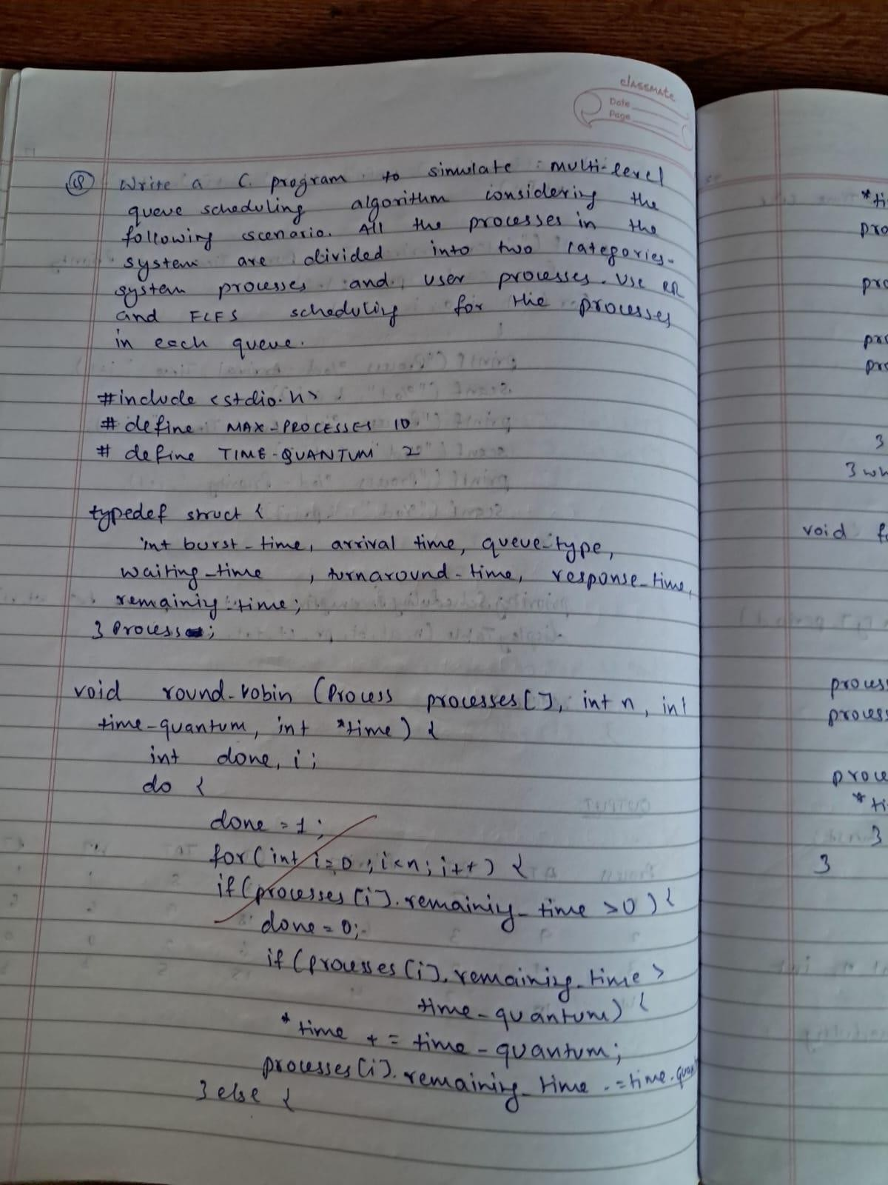

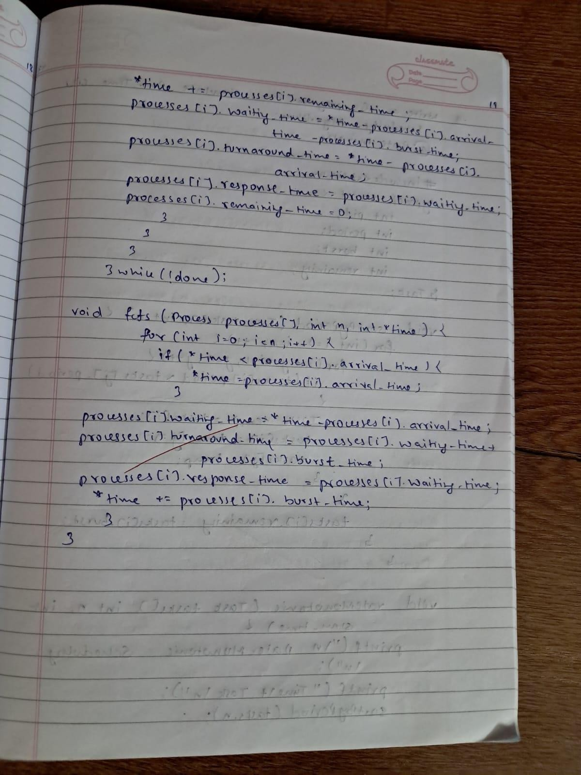

**Write a C program to simulate Real-Time CPU Scheduling algorithms: Rate- Monotonic**

# CODE:

#include <stdio.h>

typedef struct { int pid;

int period; int burst;

int remaining;

} Task;

void sortByPeriod(Task tasks[], int n) { for (int i = 0; i < n; i++) {

for (int j = i+1; j < n; j++) {

if (tasks[i].period > tasks[j].period) { Task temp = tasks[i];

tasks[i] = tasks[j]; tasks[j] = temp;

}

}

tasks[i].remaining = tasks[i].burst;

}

}

void rateMonotonic(Task tasks[], int n, int sim_time) { printf("\nRate-Monotonic Scheduling:\n"); printf("Time\tTask\n");

sortByPeriod(tasks, n);

for (int time = 0; time < sim_time; time++) { int scheduled = -1;

for (int i = 0; i < n; i++) {

if (time % tasks[i].period == 0) { tasks[i].remaining = tasks[i].burst;

}

}

for (int i = 0; i < n; i++) {

if (tasks[i].remaining > 0) { scheduled = i;

break;

}

}

if (scheduled != -1) { tasks[scheduled].remaining--;

printf("%d\tT%d\n", time, tasks[scheduled].pid);

} else {

printf("%d\tIdle\n", time);

}

}

}

int main() {

int n, sim_time;

printf("Enter number of tasks: "); scanf("%d", &n);

Task tasks[n];

for (int i = 0; i < n; i++) { tasks[i].pid = i+1;

printf("Enter period and burst time for task T%d: ", i+1); scanf("%d %d", &tasks[i].period, &tasks[i].burst);

}

printf("Enter simulation time: "); scanf("%d", &sim_time);

rateMonotonic(tasks, n, sim_time);

return 0;

}

# OUTPUT:

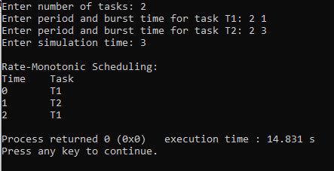

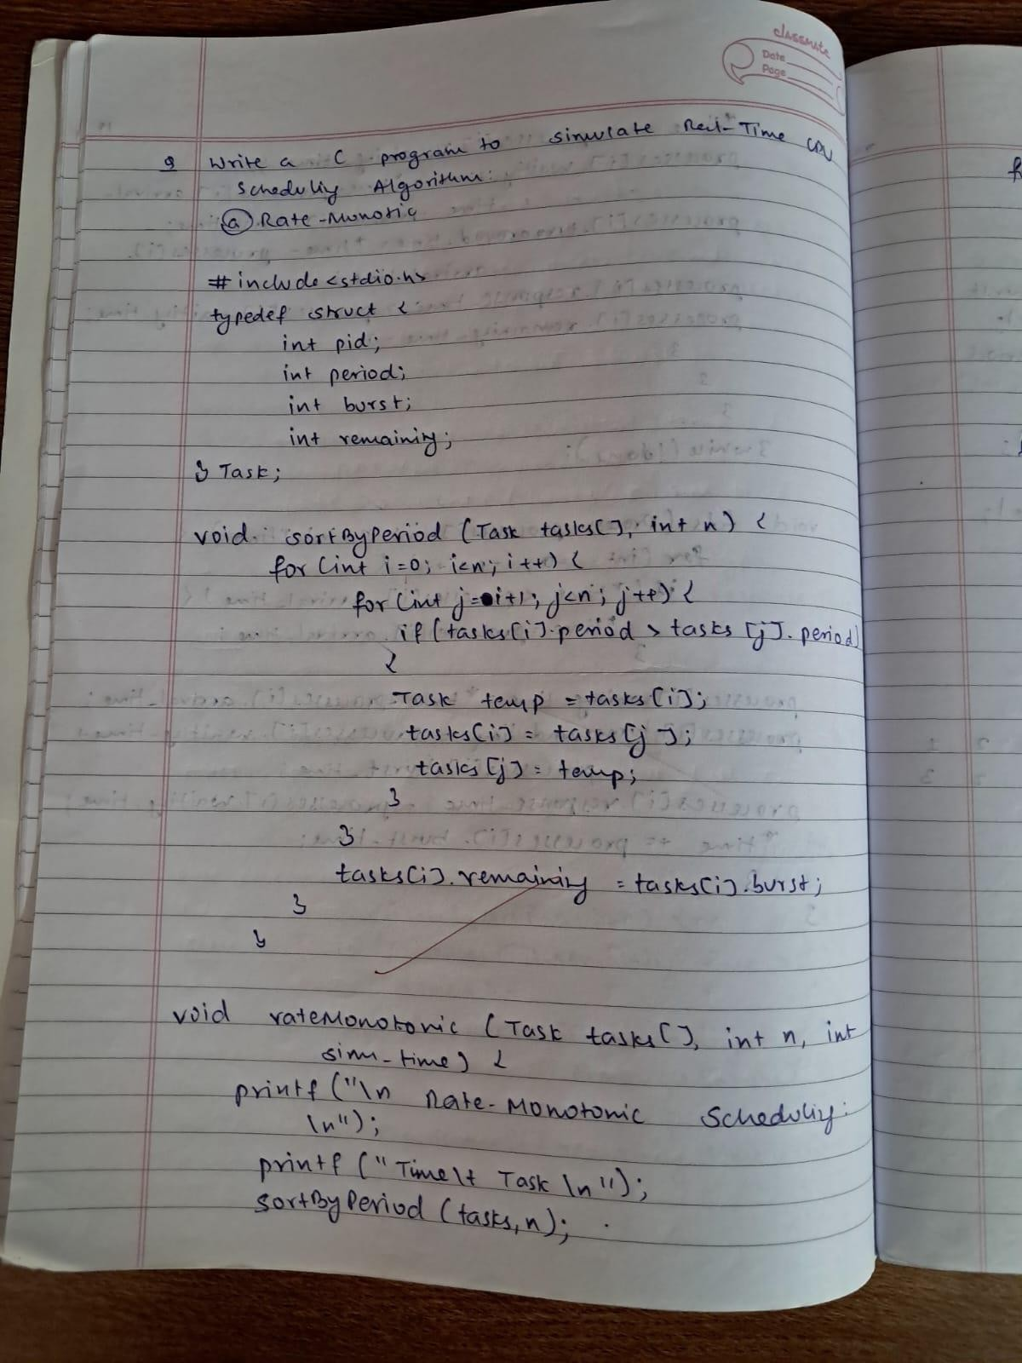

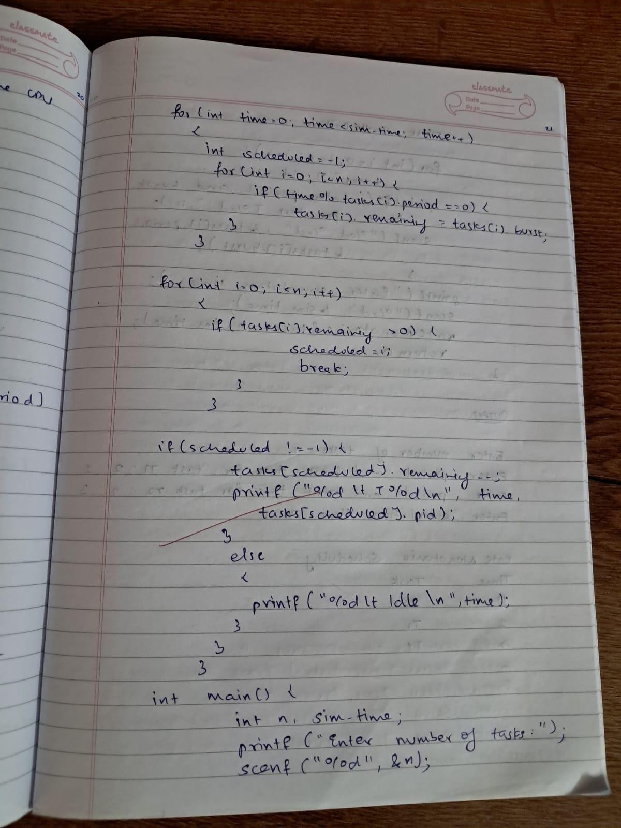

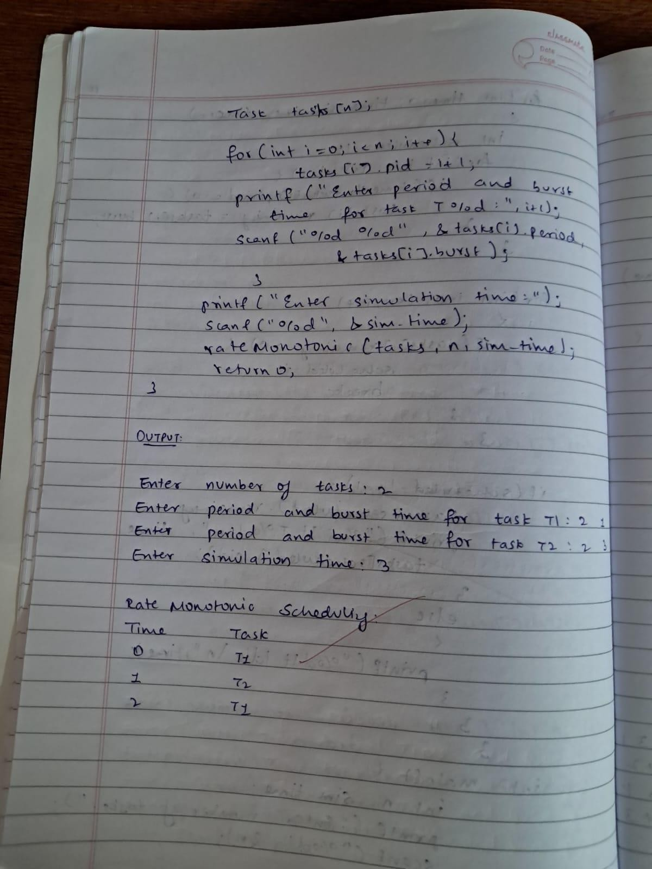

**Write a C program to simulate Real-Time CPU Scheduling algorithms: Earliest-deadline First**

# CODE:

#include <stdio.h>

#define MAX_TASKS 10

#define MAX_JOBS 1000

typedef struct {

int id, capacity, deadline, period;

} Task;

typedef struct {

int task_id, remaining_time, absolute_deadline, release_time, completed;

} Job;

int gcd(int a, int b) {

return b == 0 ? a : gcd(b, a % b);

}

int lcm(int a, int b) { return (a / gcd(a, b)) * b;

}

int lcm_of_periods(Task tasks[], int k) { int l = tasks[0].period;

for (int i = 1; i < k; i++) {

l = lcm(l, tasks[i].period);

}

return l;

}

int main() {

int k, hyperperiod;

Task tasks[MAX_TASKS]; Job jobs[MAX_JOBS];

printf("Enter the number of tasks (max %d): ", MAX_TASKS); scanf("%d", &k);

for (int i = 0; i < k; i++) { tasks[i].id = i + 1;

printf("Enter capacity, deadline, and period for task %d: ", tasks[i].id); scanf("%d %d %d", &tasks[i].capacity, &tasks[i].deadline, &tasks[i].period);

}

hyperperiod = lcm_of_periods(tasks, k);

printf("\nLCM (Hyperperiod) of periods: %d\n", hyperperiod);

int job_count = 0;

for (int i = 0; i < k; i++) {

for (int release_time = 0; release_time < hyperperiod; release_time += tasks[i].period) { jobs[job_count++] = (Job){tasks[i].id, tasks[i].capacity, release_time +

tasks[i].deadline, release_time, 0};

}

}

printf("\nTime : Running Task\n");

for (int time = 0; time < hyperperiod; time++) {

int selected_job_index = -1, earliest_deadline = 1e6;

0) {

for (int j = 0; j < job_count; j++) {

if (!jobs[j].completed && jobs[j].release_time <= time && jobs[j].remaining_time >

if (jobs[j].absolute_deadline < earliest_deadline) { earliest_deadline = jobs[j].absolute_deadline; selected_job_index = j;

}

}

}

if (selected_job_index == -1) { printf("%4d : Idle\n", time);

} else {

jobs[selected_job_index].remaining_time--;

printf("%4d : Task %d\n", time, jobs[selected_job_index].task_id); if (jobs[selected_job_index].remaining_time == 0) {

if (time + 1 > jobs[selected_job_index].absolute_deadline) {

printf(" --> Task %d missed its deadline at time %d\n", jobs[selected_job_index].task_id, time + 1);

}

jobs[selected_job_index].completed = 1;

}

}

}

return 0;

}

# OUTPUT:

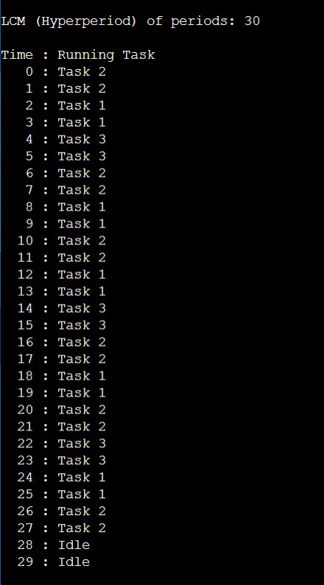

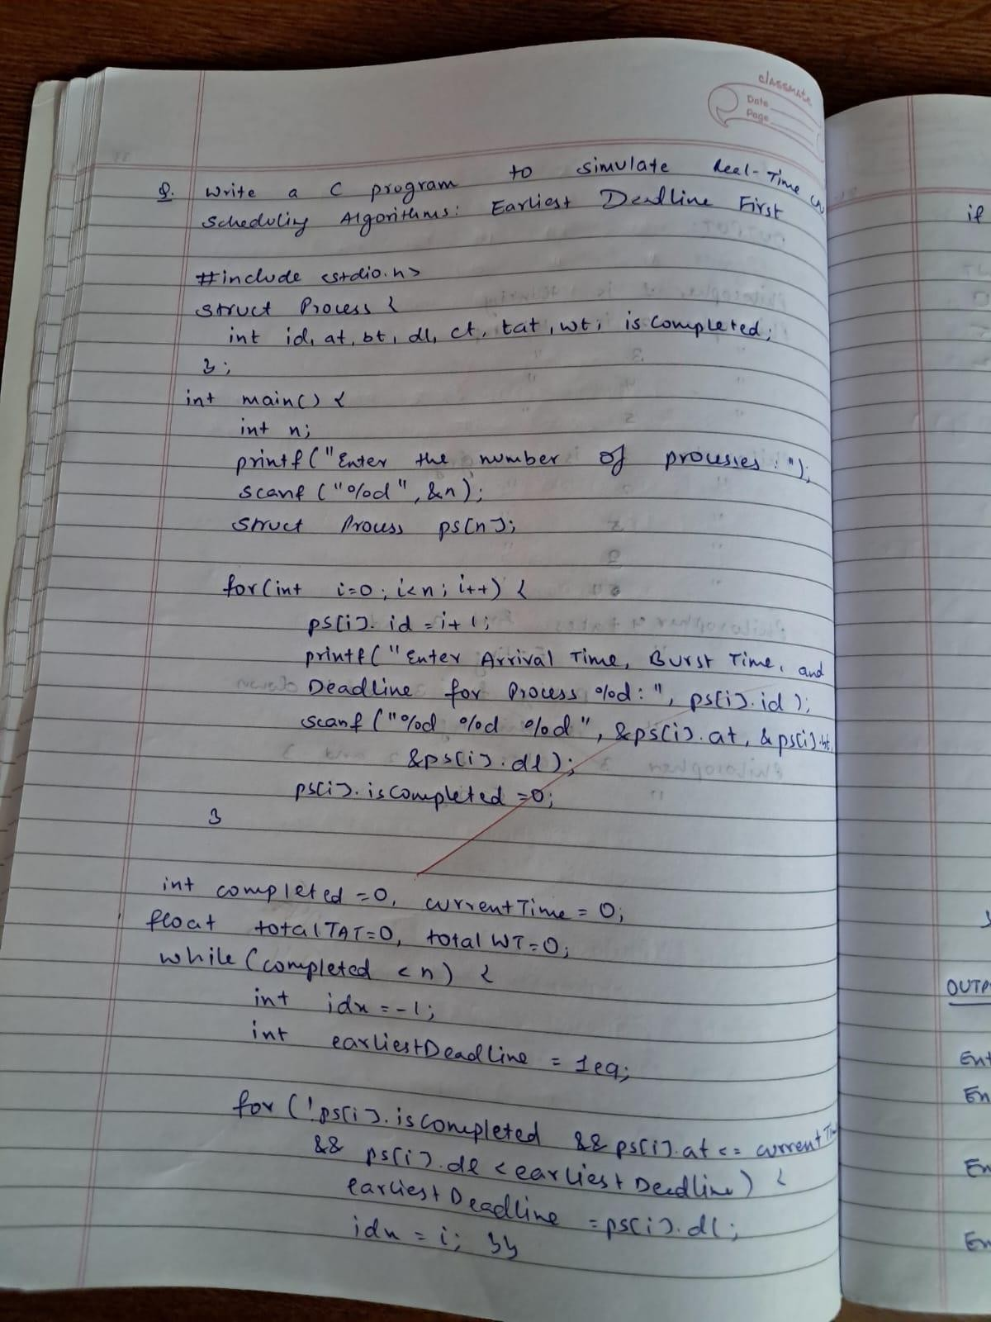

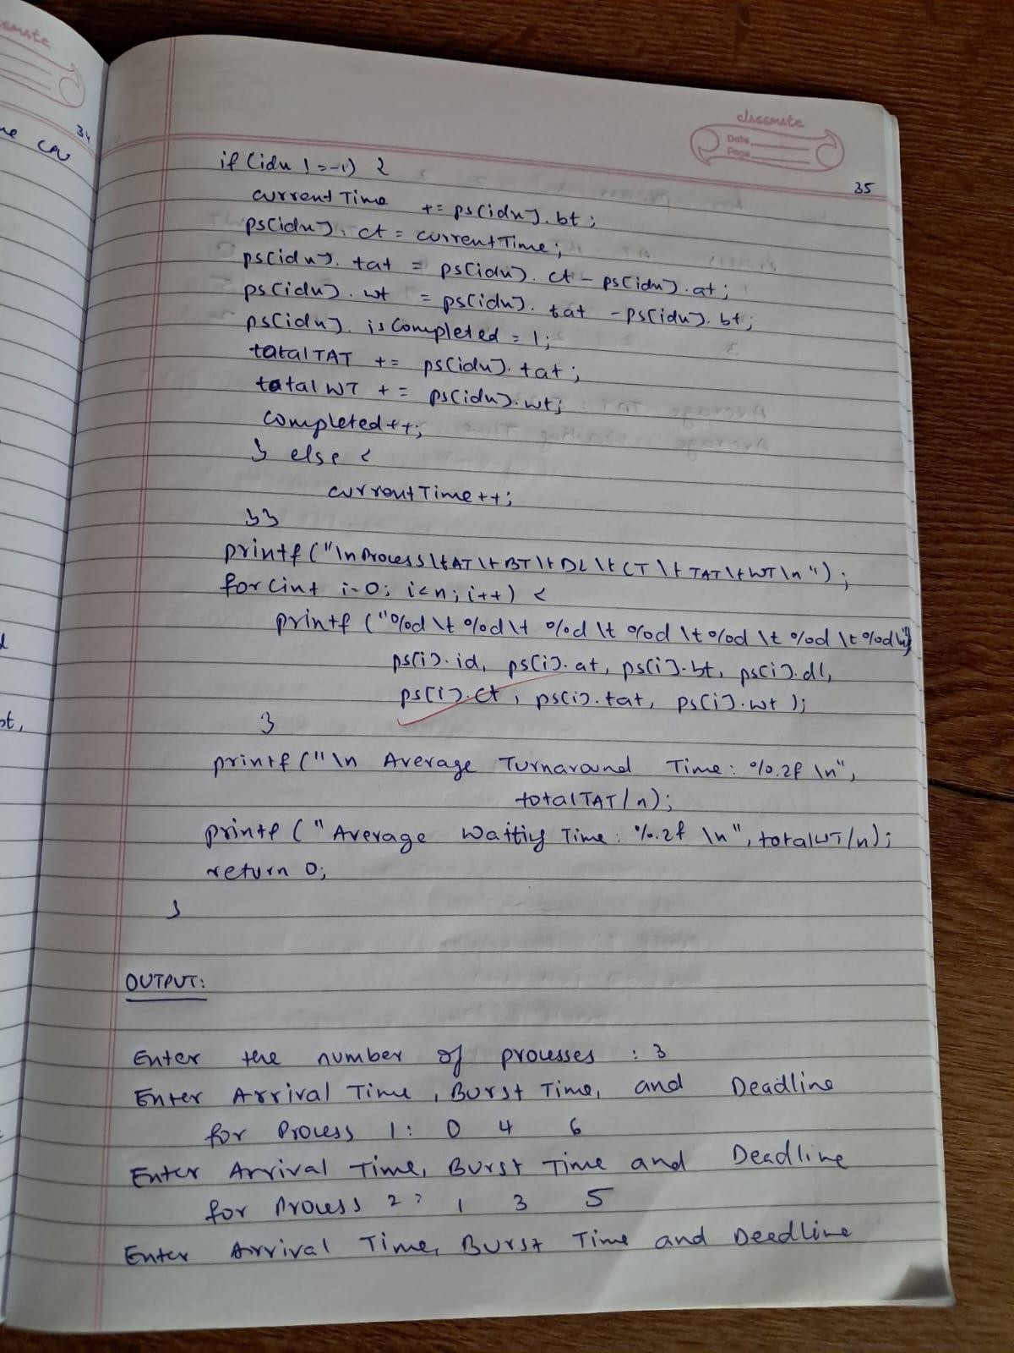

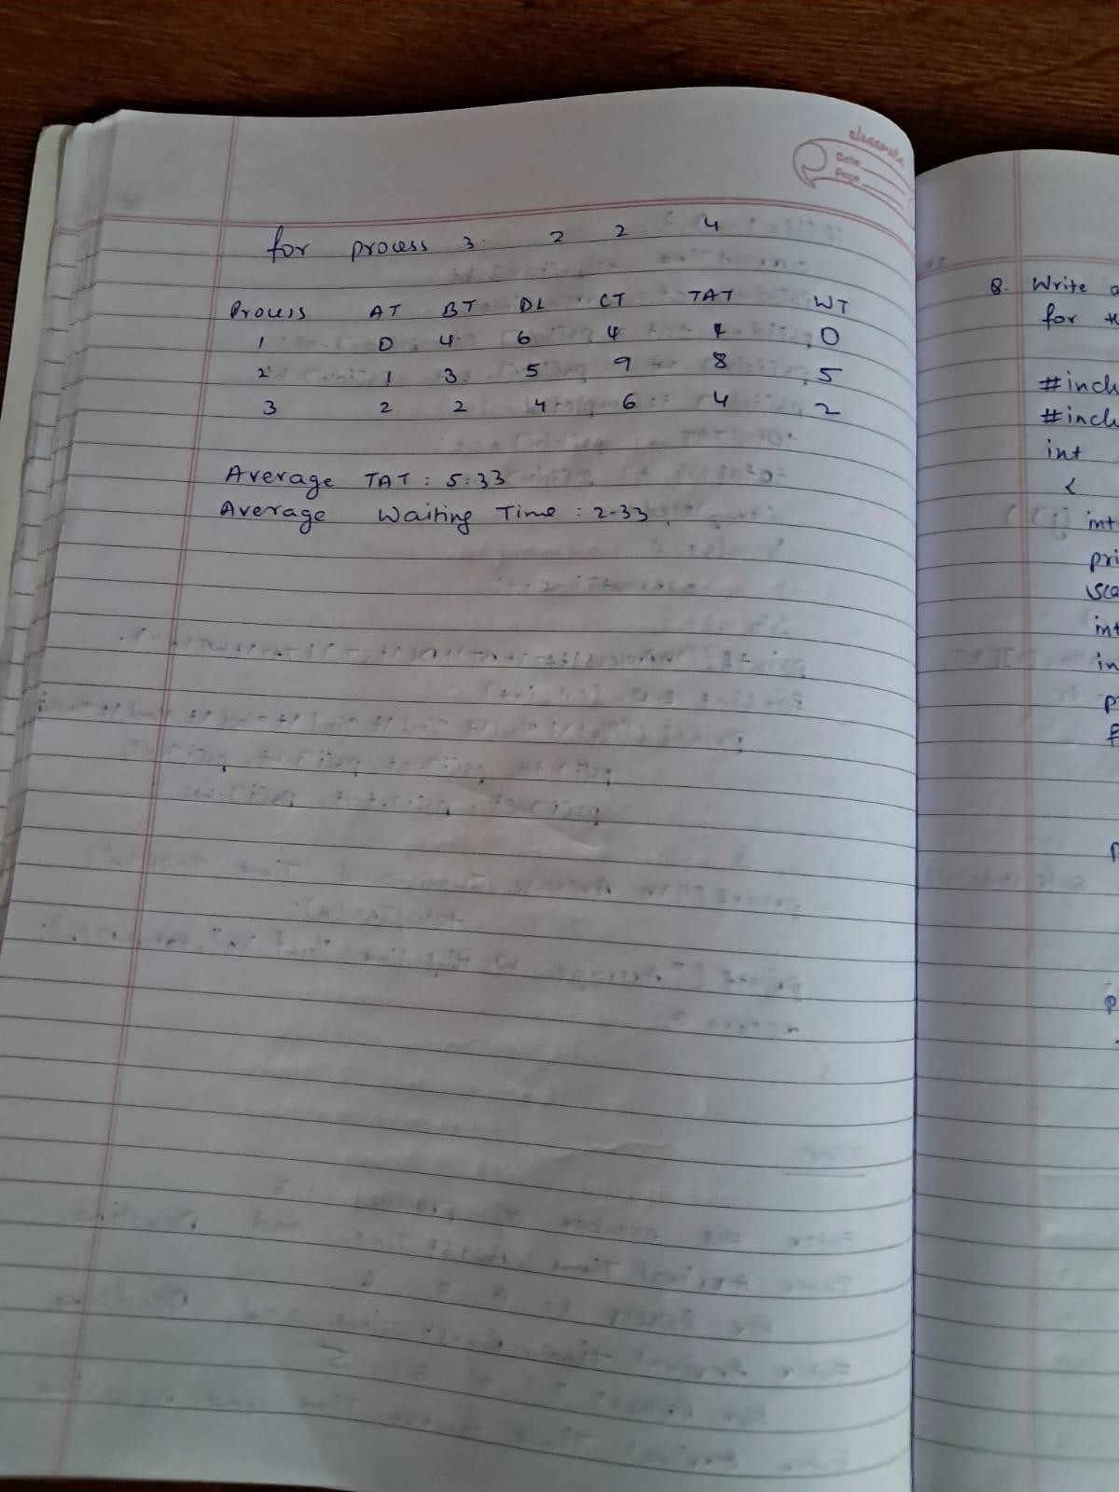

**Write a C program to simulate:**

**Producer-Consumer problem using semaphores. CODE:**

#include <stdio.h> #include <stdlib.h>

int mutex = 1; int full = 0; int empty = 3; int x = 0;

int wait(int s); int signal(int s); void producer(); void consumer();

int main() { int choice;

printf("Producer-Consumer Problem using Semaphores (Buffer size = 3)\n");

while (1) { printf("\nMenu:\n"); printf("1. Produce\n"); printf("2. Consume\n"); printf("3. Exit\n"); printf("Enter your choice: "); scanf("%d", &choice);

switch (choice) { case 1:

if ((mutex == 1) && (empty != 0)) producer();

else

printf("Buffer is full! Cannot produce.\n"); break;

case 2:

if ((mutex == 1) && (full != 0)) consumer();

else

printf("Buffer is empty! Cannot consume.\n"); break;

case 3:

exit(0);

default:

printf("Invalid choice. Try again.\n");

}

}

return 0;

}

int wait(int s) { return (--s);

}

int signal(int s) { return (++s);

}

void producer() { mutex = wait(mutex); full = signal(full); empty = wait(empty);

x++;

printf("Producer produced item %d\n", x);

mutex = signal(mutex);

}

void consumer() { mutex = wait(mutex); full = wait(full);

empty = signal(empty);

printf("Consumer consumed item %d\n", x); x--;

mutex = signal(mutex);

}

# OUTPUT:

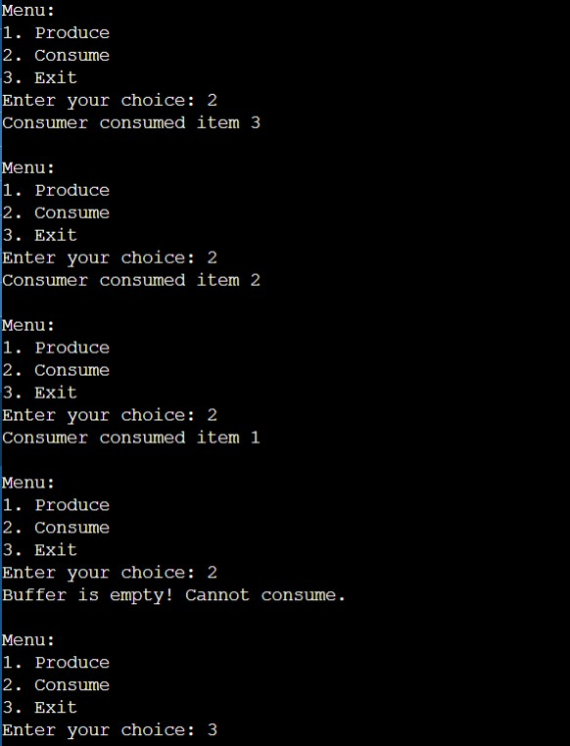

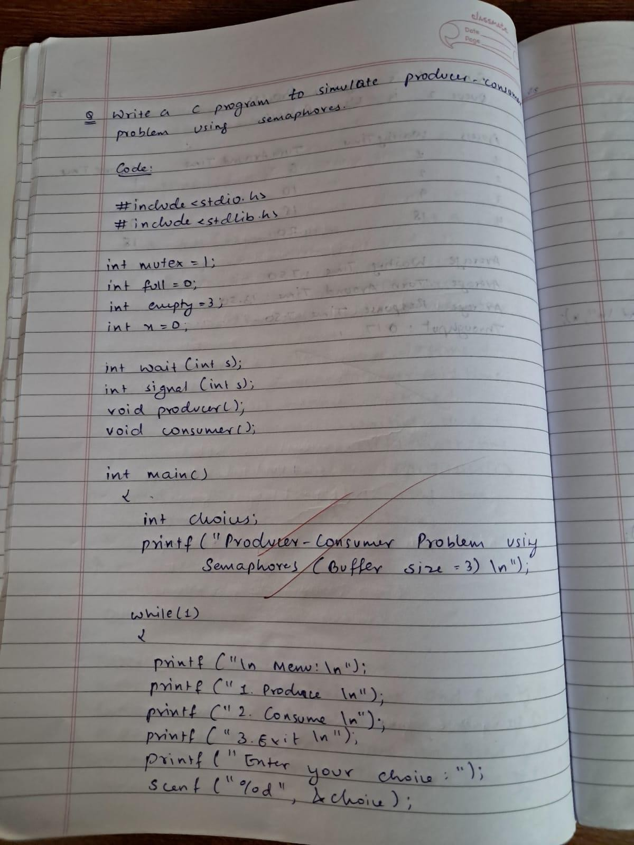

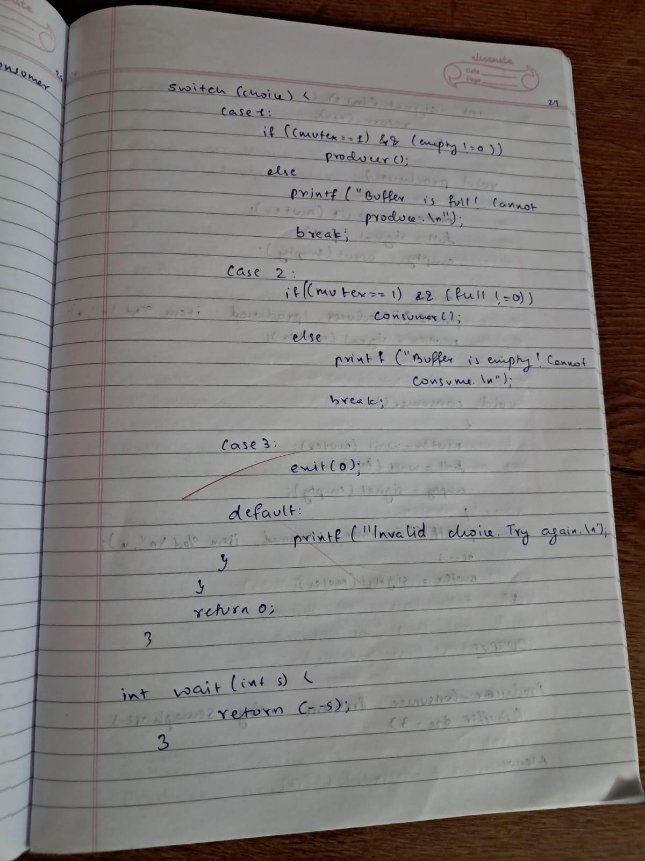

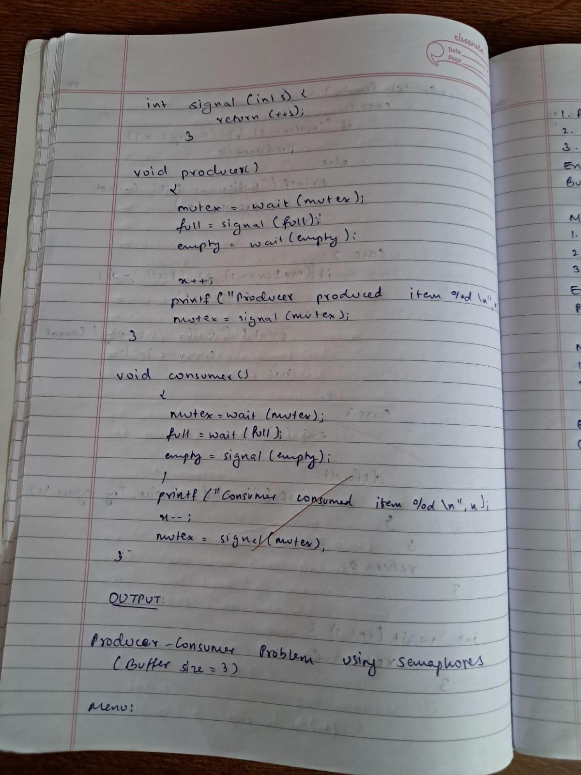

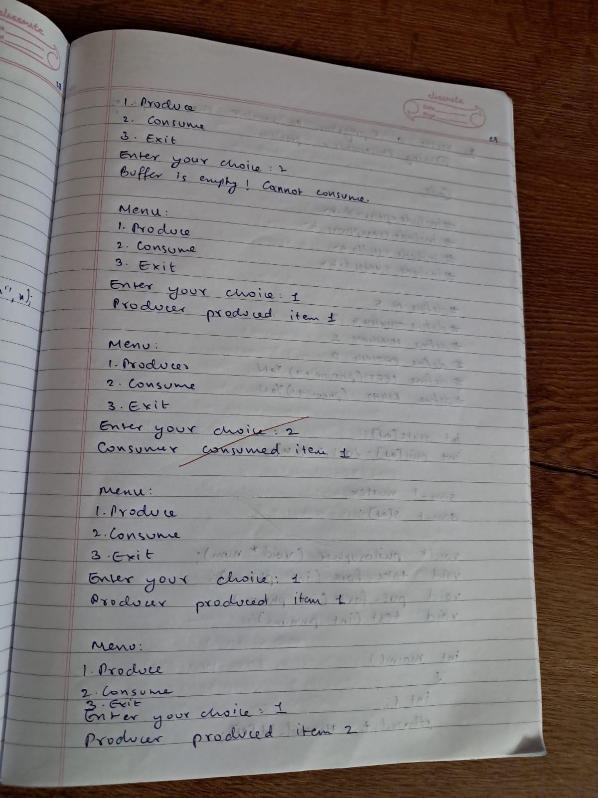

**Write a C program to simulate: Dining-Philosopher’s problem CODE:**

#include <pthread.h> #include <semaphore.h> #include <stdio.h> #include <unistd.h>

#define N 5

#define THINKING 2

#define HUNGRY 1

#define EATING 0

#define LEFT (phnum + 4) % N #define RIGHT (phnum + 1) % N

int state[N];

int phil[N] = { 0, 1, 2, 3, 4 };

sem_t mutex; sem_t S[N];

void* philosopher(void* num); void take_fork(int phnum); void put_fork(int phnum); void test(int phnum);

int main() { int i;

pthread_t thread_id[N];

// initialize the semaphores sem_init(&mutex, 0, 1); for (i = 0; i < N; i++)

sem_init(&S[i], 0, 0);

for (i = 0; i < N; i++) {

pthread_create(&thread_id[i], NULL, philosopher, &phil[i]); printf("Philosopher %d is thinking\n", i + 1);

}

for (i = 0; i < N; i++) pthread_join(thread_id[i], NULL);

return 0;

}

void test(int phnum) {

if (state[phnum] == HUNGRY && state[LEFT] != EATING && state[RIGHT] != EATING) {

// state that eating state[phnum] = EATING;

sleep(2);

printf("Philosopher %d takes fork %d and %d\n", phnum + 1, LEFT + 1, phnum + 1); printf("Philosopher %d is Eating\n", phnum + 1);

sem_post(&S[phnum]);

}

}

void take_fork(int phnum) { sem_wait(&mutex);

state[phnum] = HUNGRY;

printf("Philosopher %d is Hungry\n", phnum + 1);

test(phnum);

sem_post(&mutex);

sem_wait(&S[phnum]); sleep(1);

}

void put_fork(int phnum) { sem_wait(&mutex);

state[phnum] = THINKING;

printf("Philosopher %d putting fork %d and %d down\n", phnum + 1, LEFT + 1, phnum + 1);

printf("Philosopher %d is thinking\n", phnum + 1);

test(LEFT); test(RIGHT);

sem_post(&mutex);

}

void* philosopher(void* num) { int* i = num;

while (1) {

sleep(1); take_fork(*i); sleep(0); put_fork(*i);

}

}

# OUTPUT:

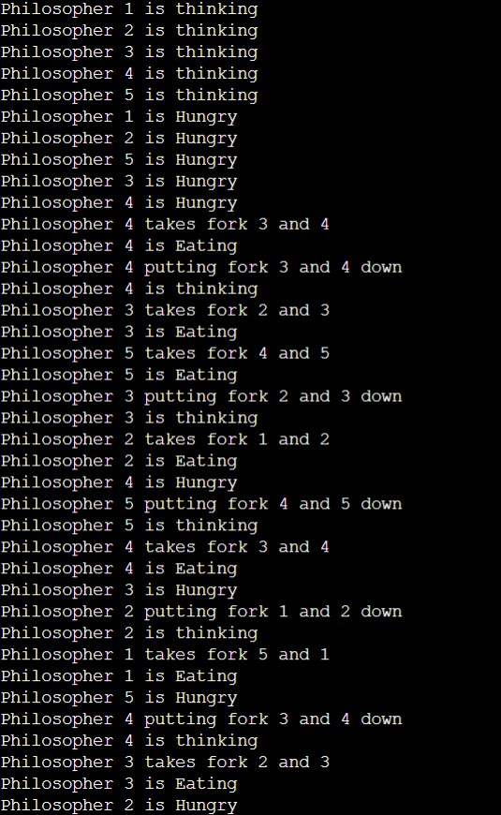

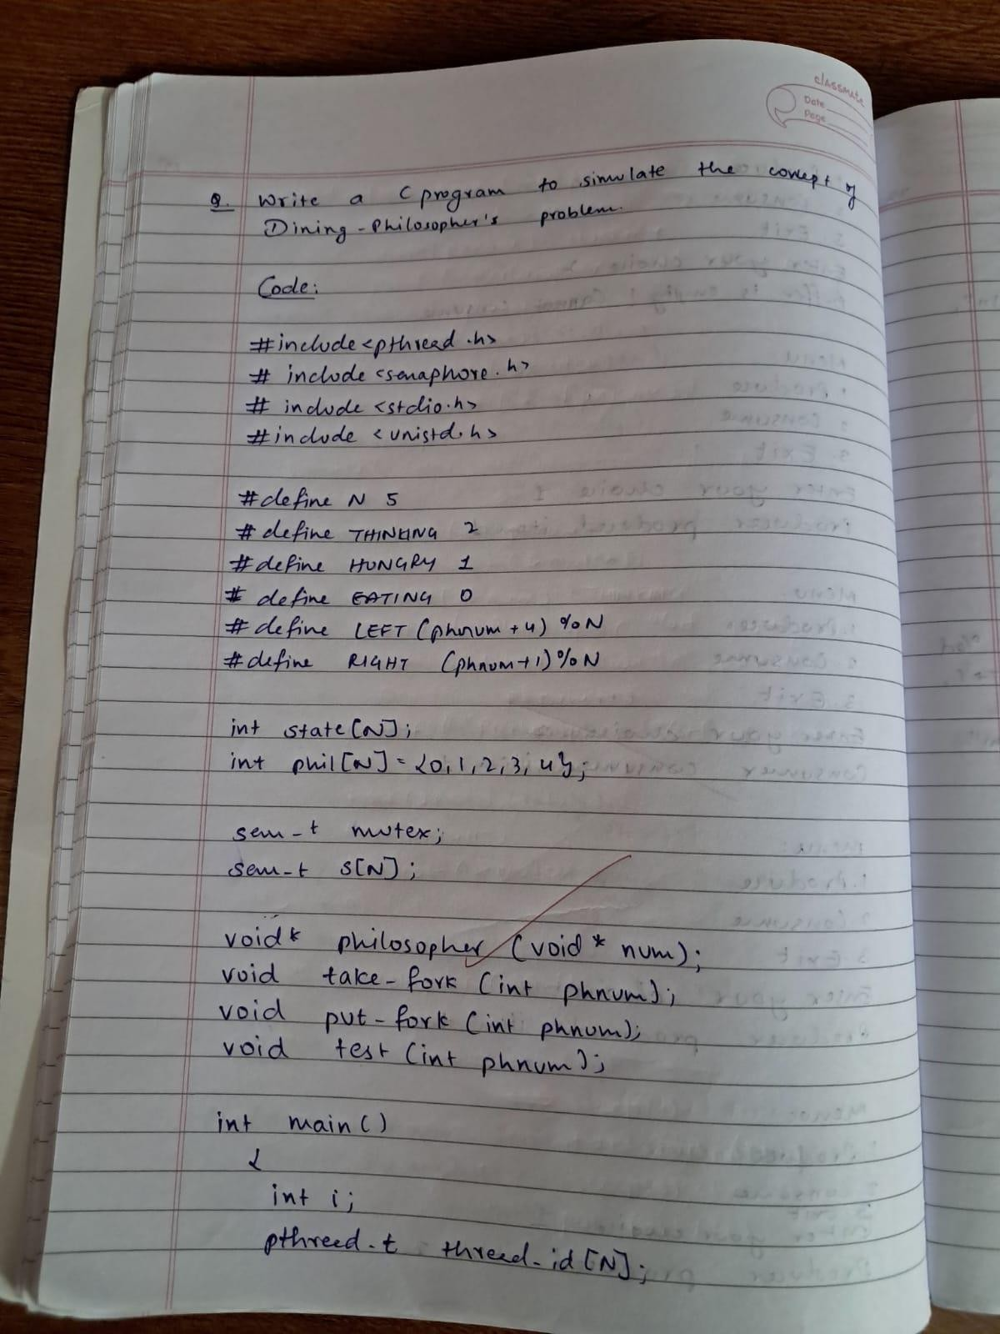

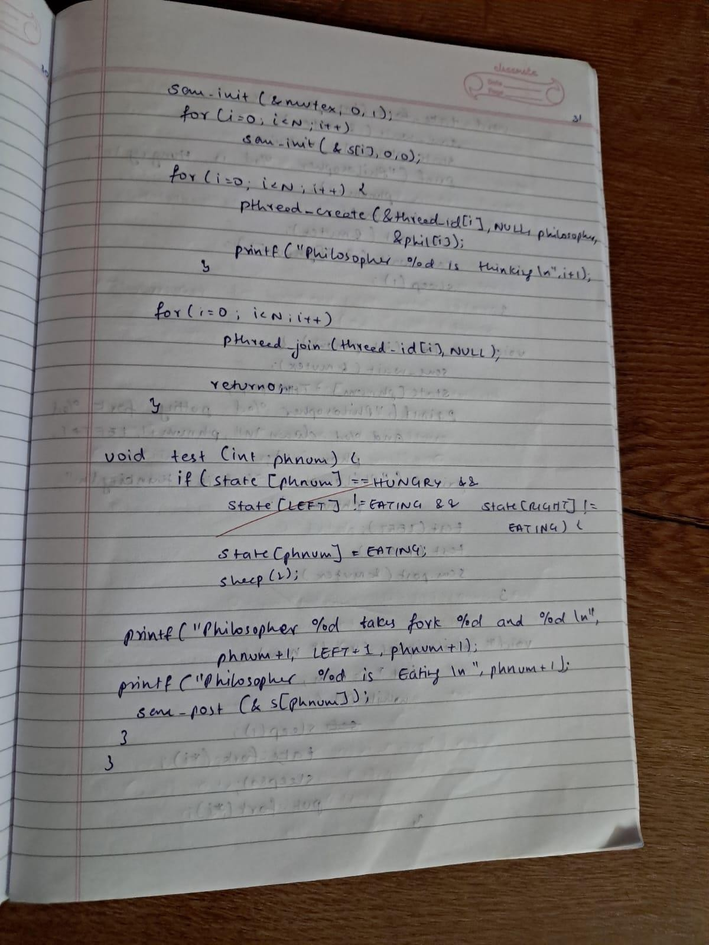

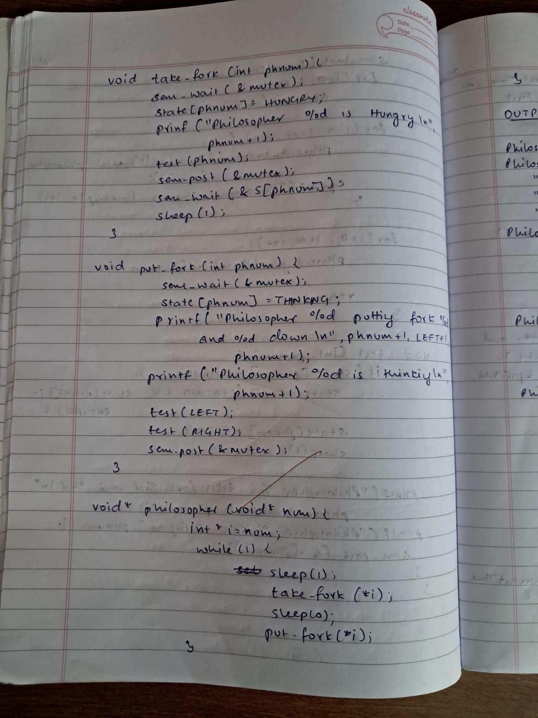

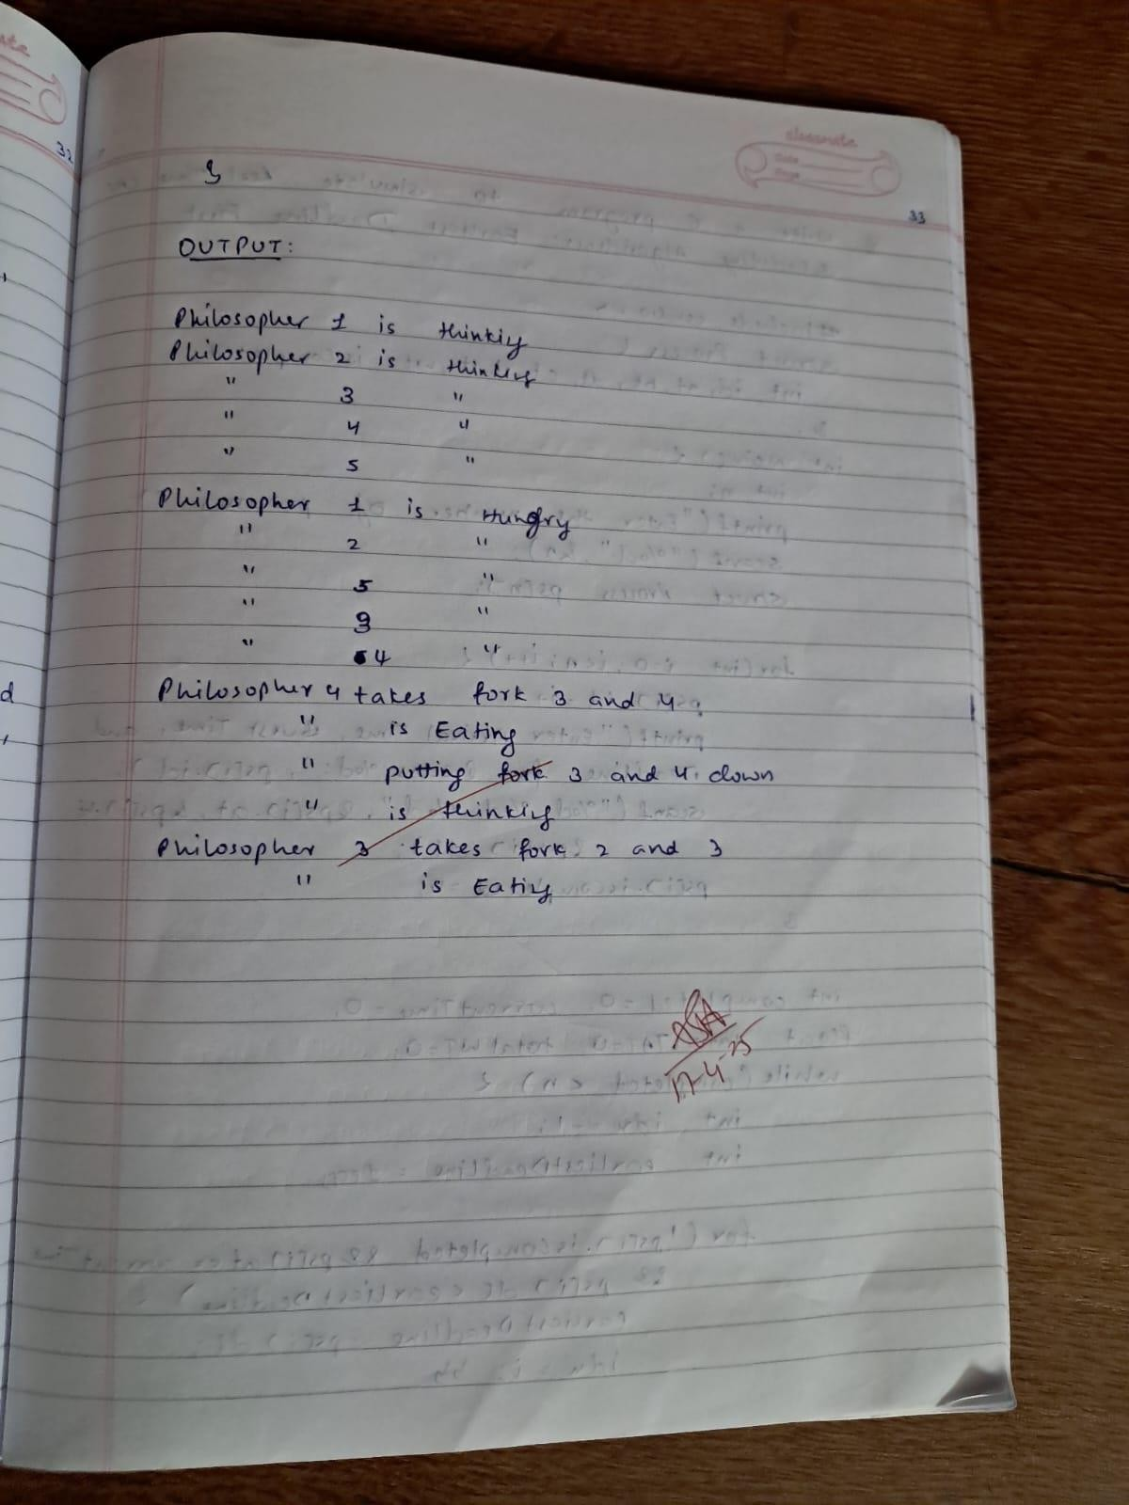

**Write a C program to simulate:**

**Bankers’ algorithm for the purpose of deadlock avoidance. CODE:**

#include <stdio.h> #include <stdbool.h>

int main() {

int n, m, i, j, k;

printf("Enter number of processes and resources:\n"); scanf("%d %d", &n, &m);

int alloc[n][m], max[n][m], avail[m]; int need[n][m];

printf("Enter allocation matrix:\n"); for (i = 0; i < n; i++)

for (j = 0; j < m; j++) scanf("%d", &alloc[i][j]);

printf("Enter max matrix:\n"); for (i = 0; i < n; i++)

for (j = 0; j < m; j++) scanf("%d", &max[i][j]);

printf("Enter available matrix:\n"); for (i = 0; i < m; i++)

scanf("%d", &avail[i]);

for (i = 0; i < n; i++)

for (j = 0; j < m; j++)

need[i][j] = max[i][j] - alloc[i][j];

bool finish[n]; int safeSeq[n]; int count = 0;

for (i = 0; i < n; i++) finish[i] = false;

while (count < n) { bool found = false;

for (i = 0; i < n; i++) { if (!finish[i]) {

for (j = 0; j < m; j++)

if (need[i][j] > avail[j]) break;

if (j == m) {

for (k = 0; k < m; k++) avail[k] += alloc[i][k];

safeSeq[count++] = i; finish[i] = true;

found = true;

}

}

}

if (!found) {

printf("System is not in safe state.\n"); return 1;

}

}

printf("System is in safe state.\n"); printf("Safe sequence is: ");

for (i = 0; i < n; i++) { printf("P%d", safeSeq[i]); if (i != n - 1)

printf(" -> ");

}

printf("\n");

return 0;

}

# OUTPUT:

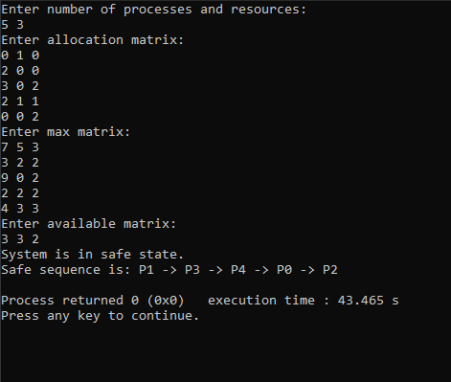

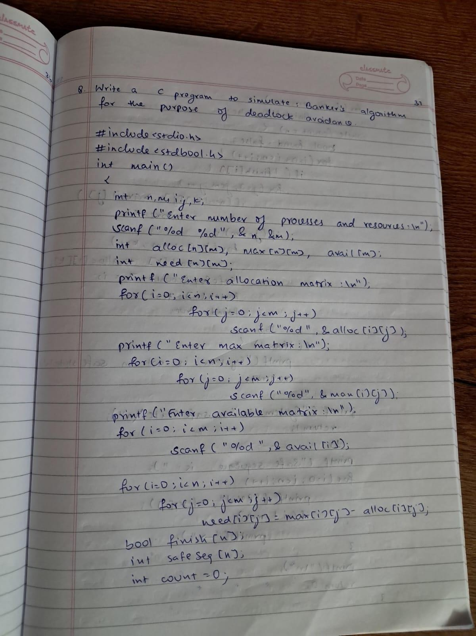

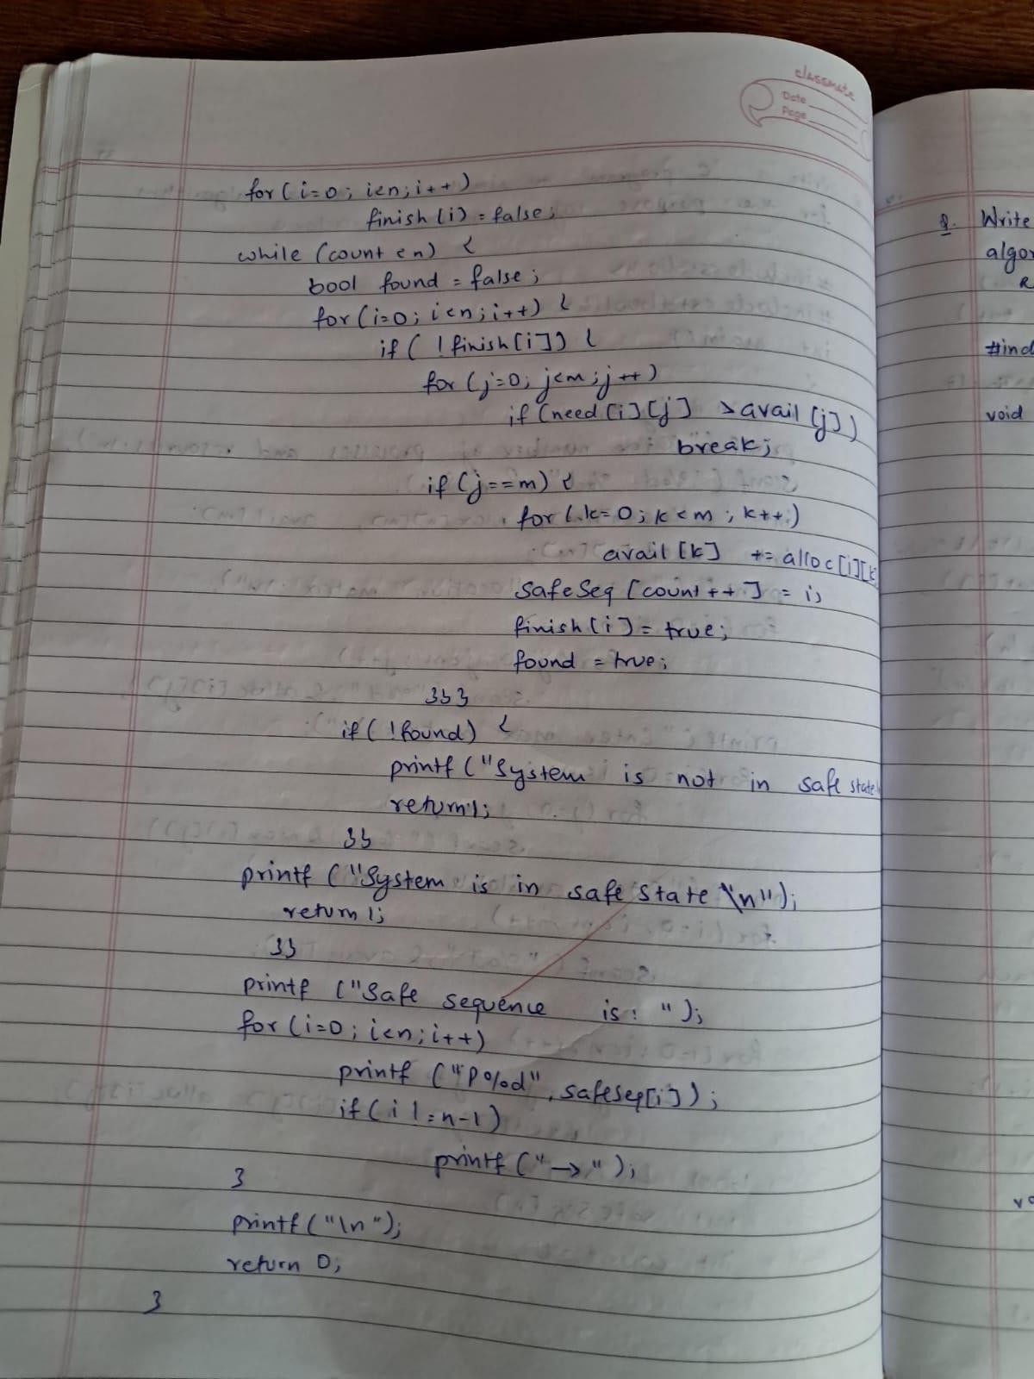

**Write a C program to simulate:**

**Deadlock Detection CODE:**

#include <stdio.h> #include <stdbool.h>

int main() {

int n, m, i, j, k;

printf("Enter number of processes and resources:\n"); scanf("%d %d", &n, &m);

int allocation[n][m], request[n][m], available[m]; int work[m];

bool finish[n];

printf("Enter allocation matrix:\n"); for (i = 0; i < n; i++)

for (j = 0; j < m; j++) scanf("%d", &allocation[i][j]);

printf("Enter request matrix:\n"); for (i = 0; i < n; i++)

for (j = 0; j < m; j++) scanf("%d", &request[i][j]);

printf("Enter available matrix:\n"); for (i = 0; i < m; i++) {

scanf("%d", &available[i]); work[i] = available[i];

}

for (i = 0; i < n; i++) {

bool zero_allocation = true; for (j = 0; j < m; j++) {

if (allocation[i][j] != 0) { zero_allocation = false; break;

}

}

finish[i] = zero_allocation;

}

bool found_process; do {

found_process = false; for (i = 0; i < n; i++) {

if (!finish[i]) {

bool can_allocate = true; for (j = 0; j < m; j++) {

if (request[i][j] > work[j]) { can_allocate = false; break;

}

}

if (can_allocate) {

for (k = 0; k < m; k++) work[k] += allocation[i][k];

finish[i] = true;

printf("Process %d can finish.\n", i);

found_process = true;

}

}

}

} while (found_process);

bool deadlock = false; for (i = 0; i < n; i++) {

if (!finish[i]) { deadlock = true; break;

}

}

if (deadlock)

printf("System is in a deadlock state.\n"); else

printf("System is not in a deadlock state.\n");

return 0;

}

# OUTPUT:

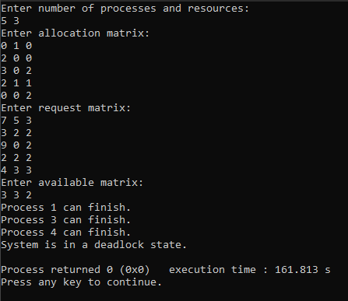

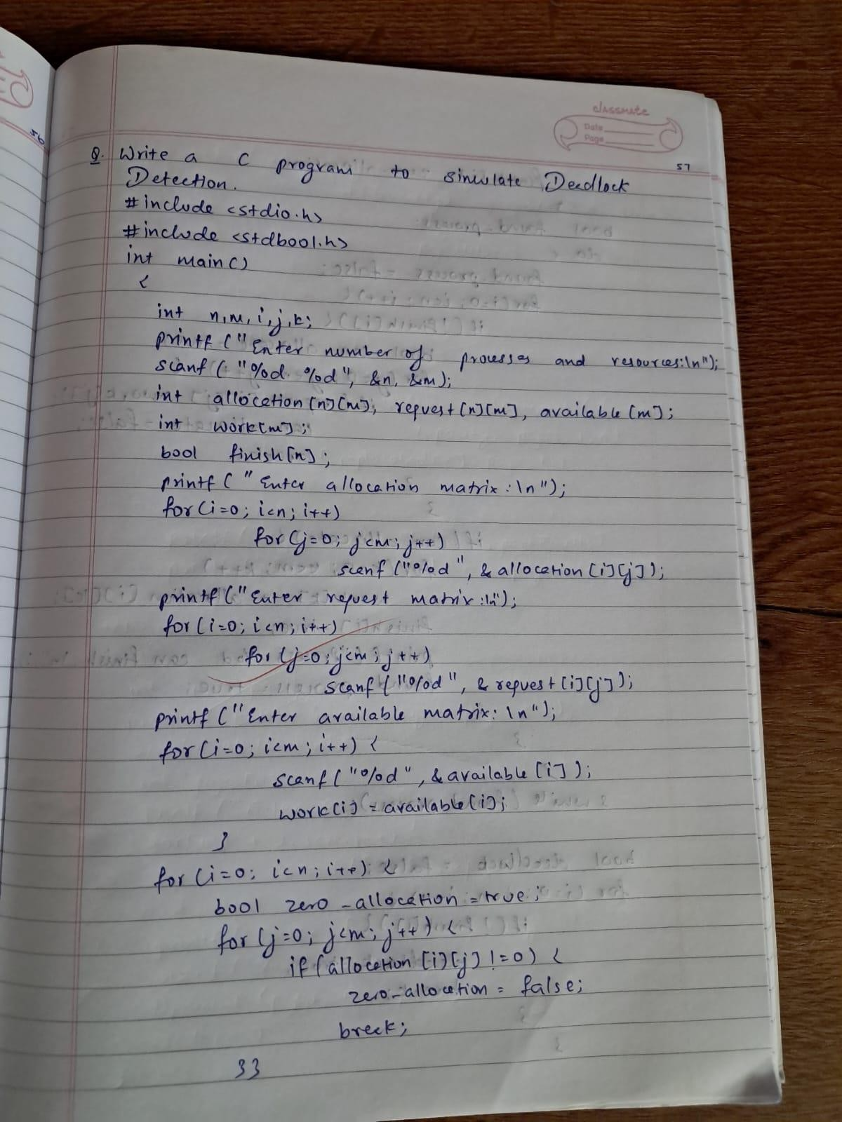

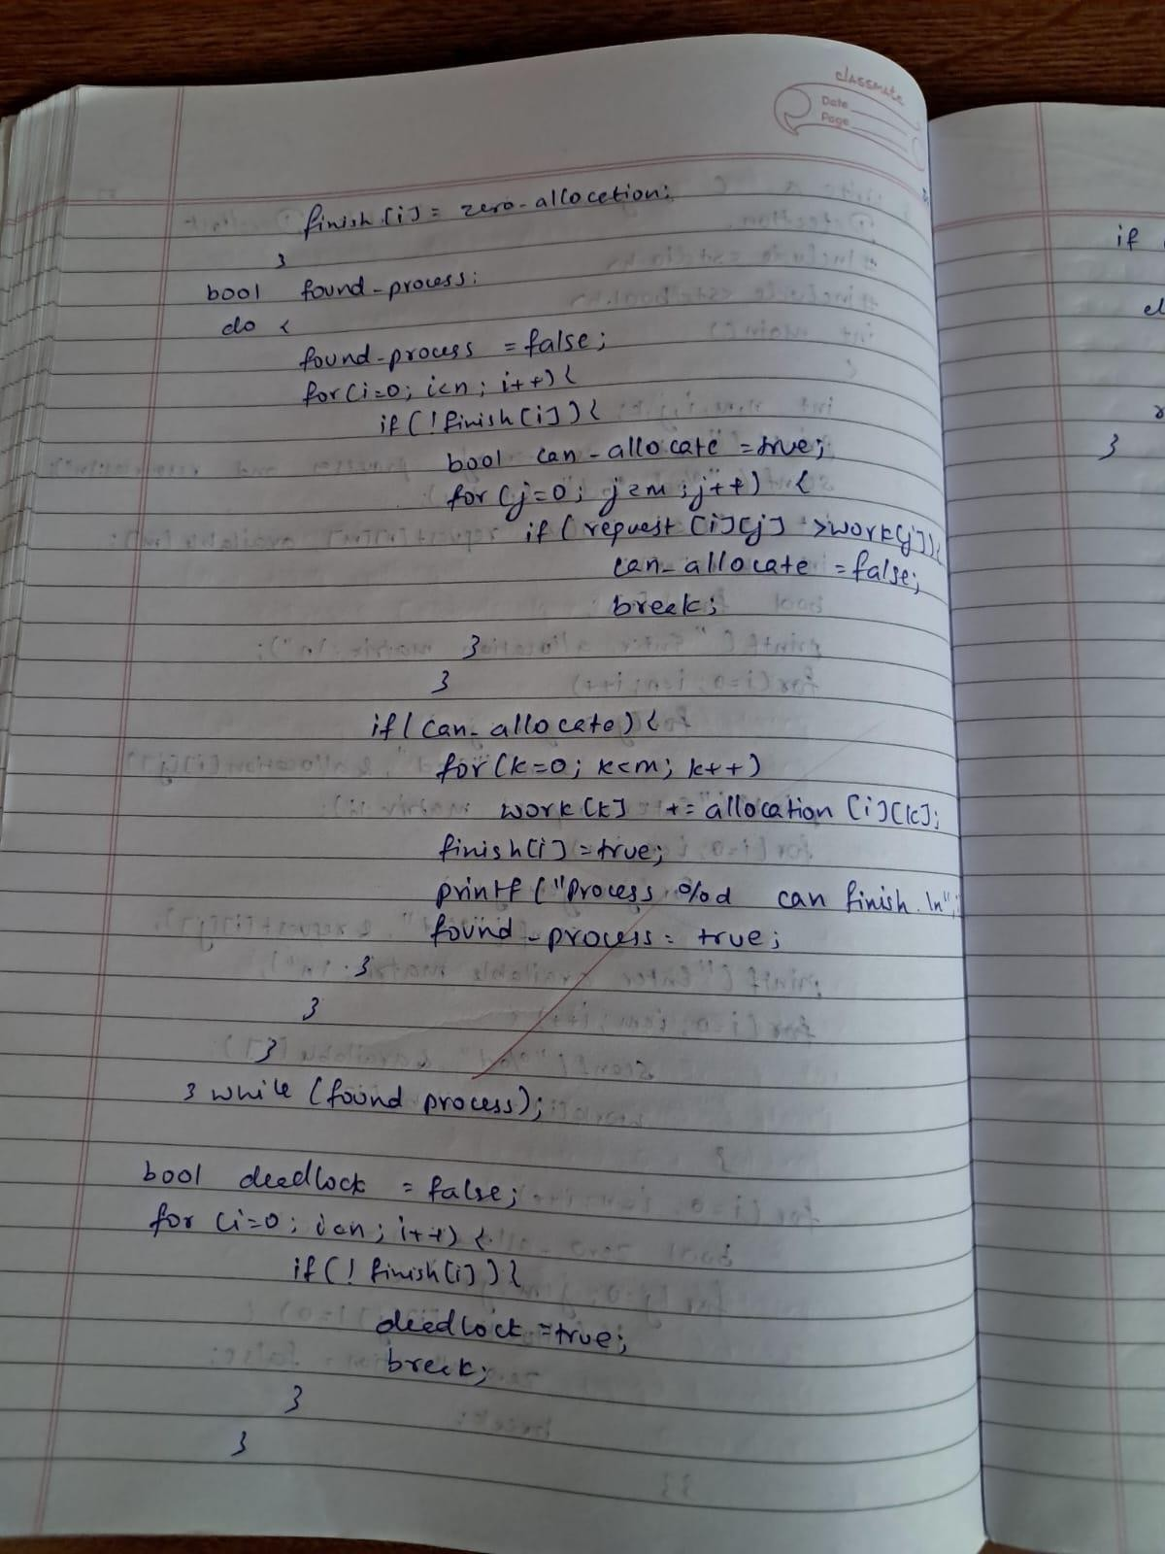

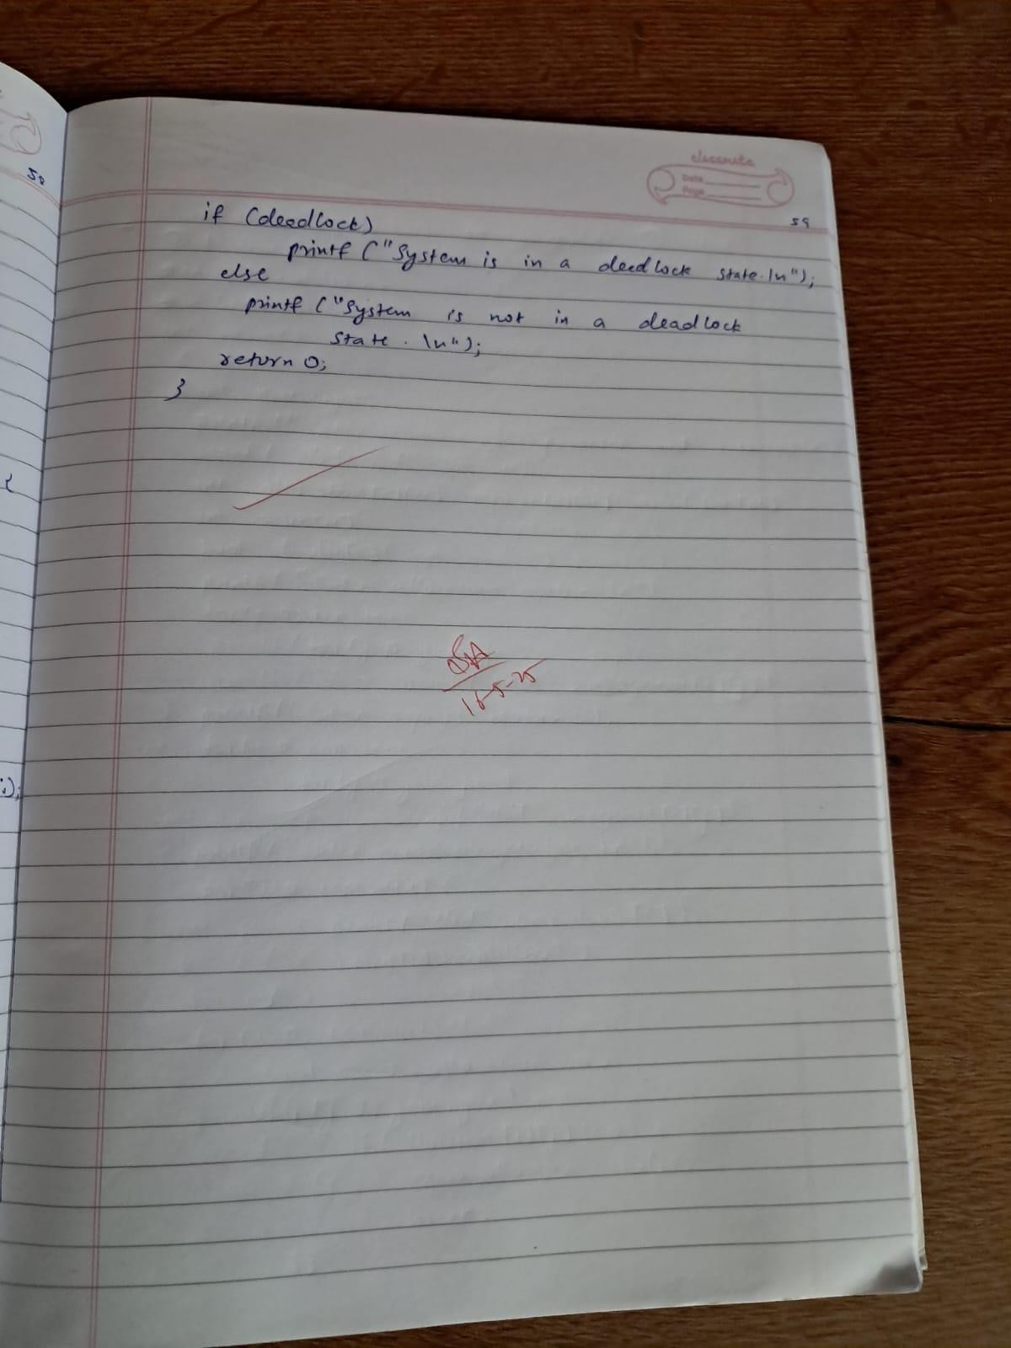

**Write a C program to simulate the following contiguous memory allocation techniques. Worst-fit**

# CODE:

#include <stdio.h>

void worstFit(int blockSize[], int m, int processSize[], int n) { int allocation[n];

for (int i = 0; i < n; i++) { allocation[i] = -1;

}

for (int i = 0; i < n; i++) { int worstIdx = -1;

for (int j = 0; j < m; j++) {

if (blockSize[j] >= processSize[i]) {

if (worstIdx == -1 || blockSize[j] > blockSize[worstIdx]) { worstIdx = j;

}

}

}

if (worstIdx != -1) {

allocation[i] = worstIdx; blockSize[worstIdx] -= processSize[i];

}

}

printf("\nProcess No\tProcess Size\tBlock No\tBlock Size\n"); for (int i = 0; i < n; i++) {

if (allocation[i] != -1) { printf("P%d\t\t%d\t\tB%d\t\t%d\n", i + 1, processSize[i],

allocation[i] + 1, blockSize[allocation[i]]);

} else {

printf("P%d\t\t%d\t\tNot Allocated\t\t-\n", i + 1, processSize[i]);

}

}

}

int main() { int m, n;

printf("Enter the number of blocks: "); scanf("%d", &m);

int blockSize[m];

printf("Enter the size of each block:\n"); for (int i = 0; i < m; i++) {

printf("Block %d size: ", i + 1); scanf("%d", &blockSize[i]);

}

printf("Enter the number of processes: "); scanf("%d", &n);

int processSize[n];

printf("Enter the size of each process:\n"); for (int i = 0; i < n; i++) {

printf("Process %d size: ", i + 1); scanf("%d", &processSize[i]);

}

worstFit(blockSize, m, processSize, n);

return 0;

}

# OUTPUT:

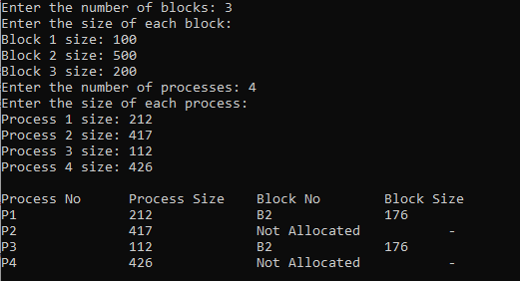

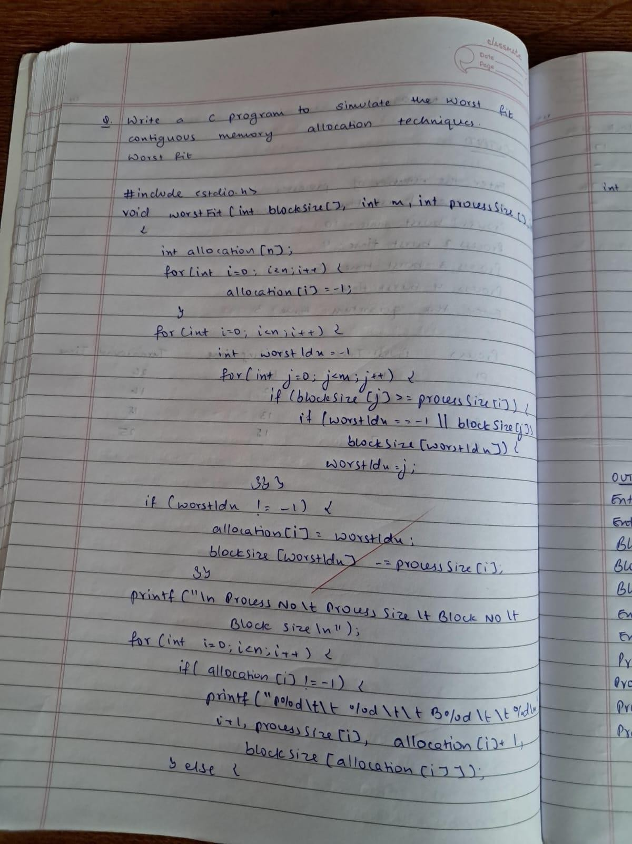

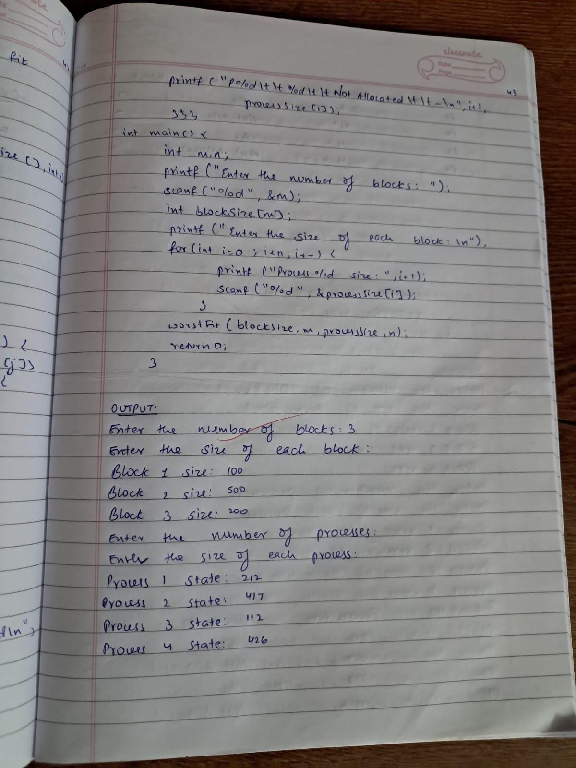

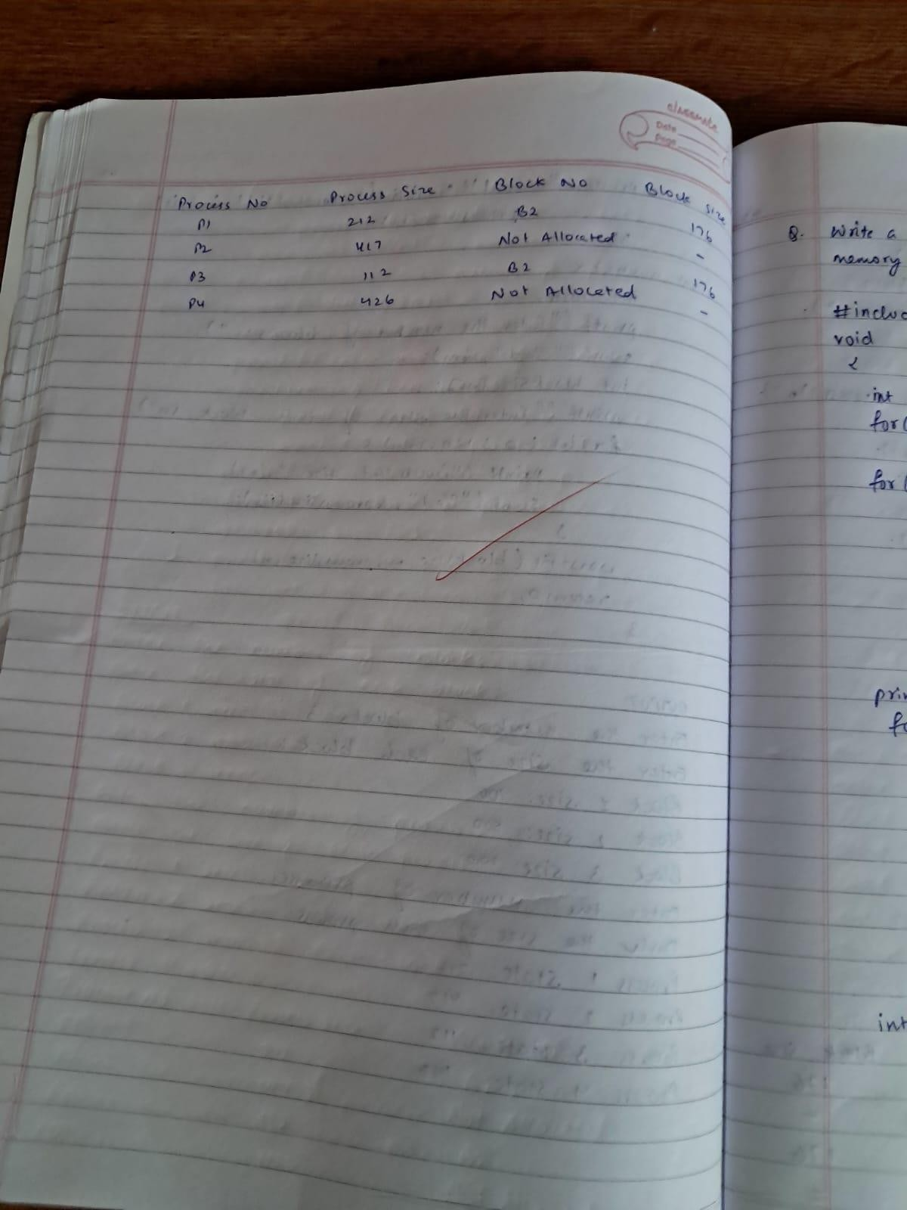

**Write a C program to simulate the following contiguous memory allocation techniques. First-fit**

# CODE:

#include <stdio.h>

void firstFit(int blockSize[], int m, int processSize[], int n) { int allocation[n];

for (int i = 0; i < n; i++) { allocation[i] = -1;

}

for (int i = 0; i < n; i++) { for (int j = 0; j < m; j++) {

if (blockSize[j] >= processSize[i]) { allocation[i] = j;

blockSize[j] -= processSize[i]; break;

}

}

}

printf("\nProcess No\tProcess Size\tBlock No\tBlock Size\n"); for (int i = 0; i < n; i++) {

if (allocation[i] != -1) { printf("P%d\t\t%d\t\tB%d\t\t%d\n", i + 1, processSize[i],

allocation[i] + 1, blockSize[allocation[i]]);

} else {

printf("P%d\t\t%d\t\tNot Allocated\t\t-\n", i + 1, processSize[i]);

}

}

}

int main() { int m, n;

printf("Enter the number of blocks: "); scanf("%d", &m);

int blockSize[m];

printf("Enter the size of each block:\n"); for (int i = 0; i < m; i++) {

printf("Block %d size: ", i + 1); scanf("%d", &blockSize[i]);

}

printf("Enter the number of processes: "); scanf("%d", &n);

int processSize[n];

printf("Enter the size of each process:\n"); for (int i = 0; i < n; i++) {

printf("Process %d size: ", i + 1); scanf("%d", &processSize[i]);

}

firstFit(blockSize, m, processSize, n);

return 0;

}

# OUTPUT:

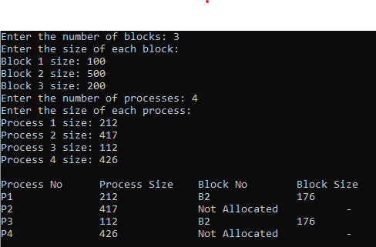

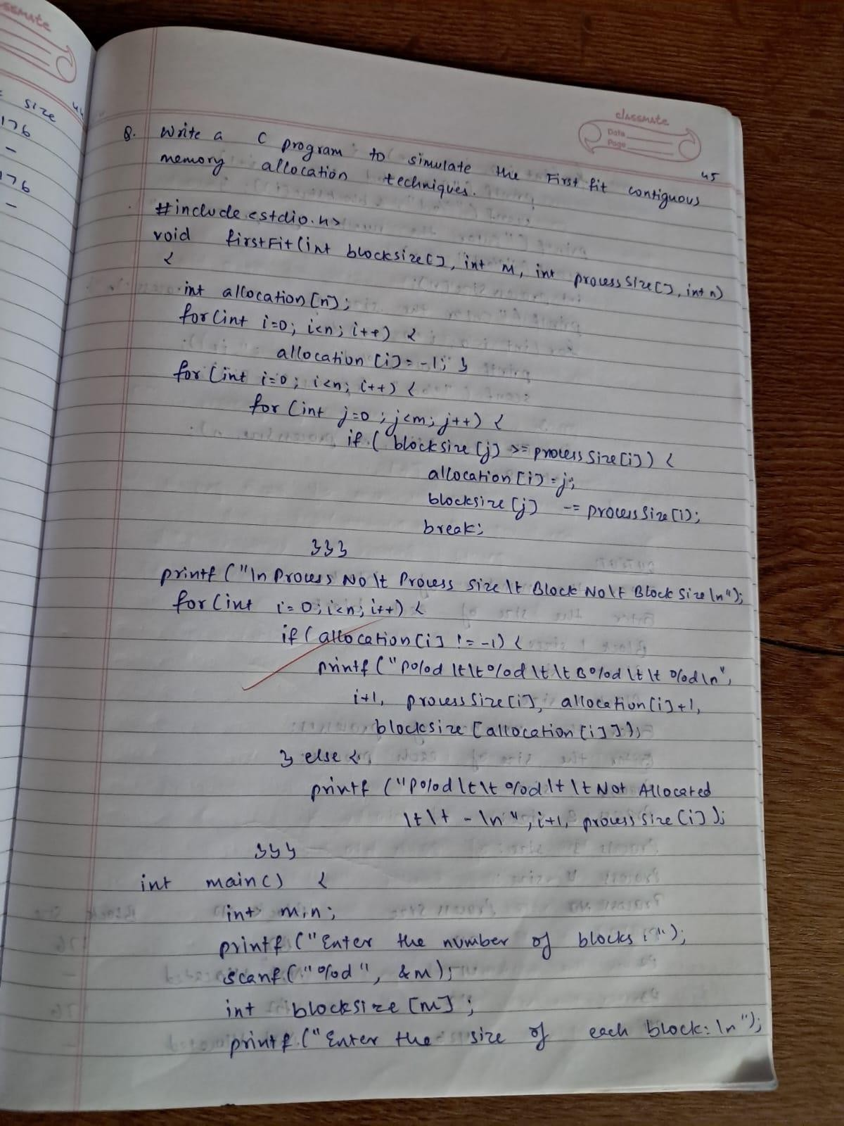

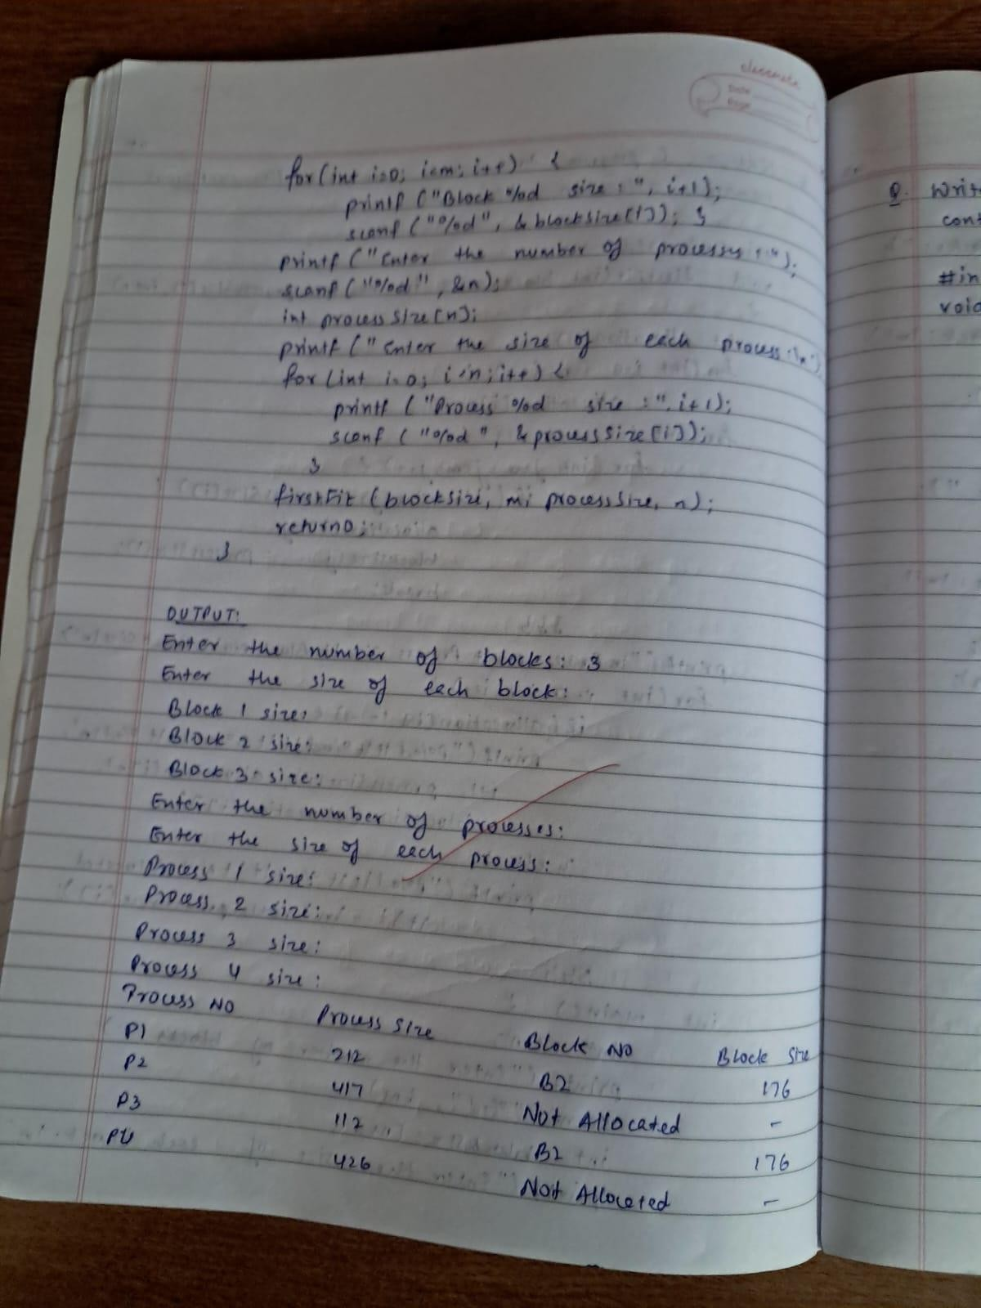

**Write a C program to simulate the following contiguous memory allocation techniques. Best-fit**

# CODE:

#include <stdio.h>

void bestFit(int blockSize[], int m, int processSize[], int n) { int allocation[n];

for (int i = 0; i < n; i++) { allocation[i] = -1;

}

for (int i = 0; i < n; i++) { int bestIdx = -1;

for (int j = 0; j < m; j++) {

if (blockSize[j] >= processSize[i]) {

if (bestIdx == -1 || blockSize[j] < blockSize[bestIdx]) { bestIdx = j;

}

}

}

if (bestIdx != -1) { allocation[i] = bestIdx;

blockSize[bestIdx] -= processSize[i];

}

}

printf("\nProcess No\tProcess Size\tBlock No\tBlock Size\n"); for (int i = 0; i < n; i++) {

if (allocation[i] != -1) {

printf("P%d\t\t%d\t\tB%d\t\t%d\n", i + 1, processSize[i], allocation[i] + 1, blockSize[allocation[i]]);

} else {

printf("P%d\t\t%d\t\tNot Allocated\t\t-\n", i + 1, processSize[i]);

}

}

}

int main() { int m, n;

printf("Enter the number of blocks: "); scanf("%d", &m);

int blockSize[m];

printf("Enter the size of each block:\n"); for (int i = 0; i < m; i++) {

printf("Block %d size: ", i + 1); scanf("%d", &blockSize[i]);

}

printf("Enter the number of processes: "); scanf("%d", &n);

int processSize[n];

printf("Enter the size of each process:\n"); for (int i = 0; i < n; i++) {

printf("Process %d size: ", i + 1); scanf("%d", &processSize[i]);

}

bestFit(blockSize, m, processSize, n);

return 0;

}

# OUTPUT:

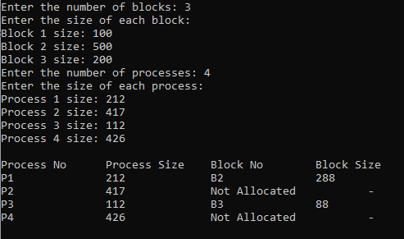

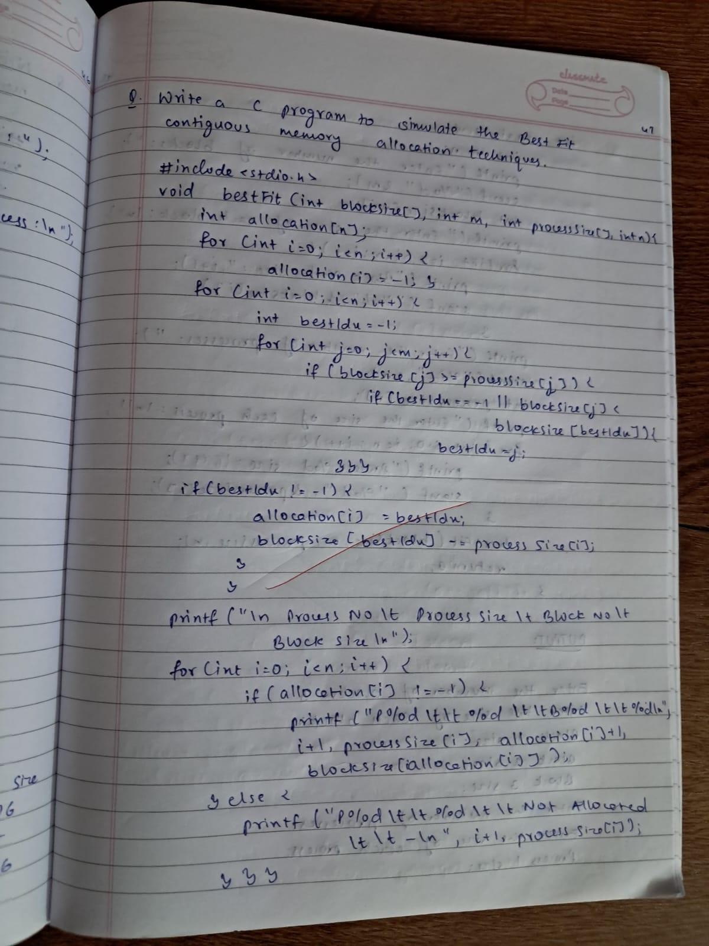

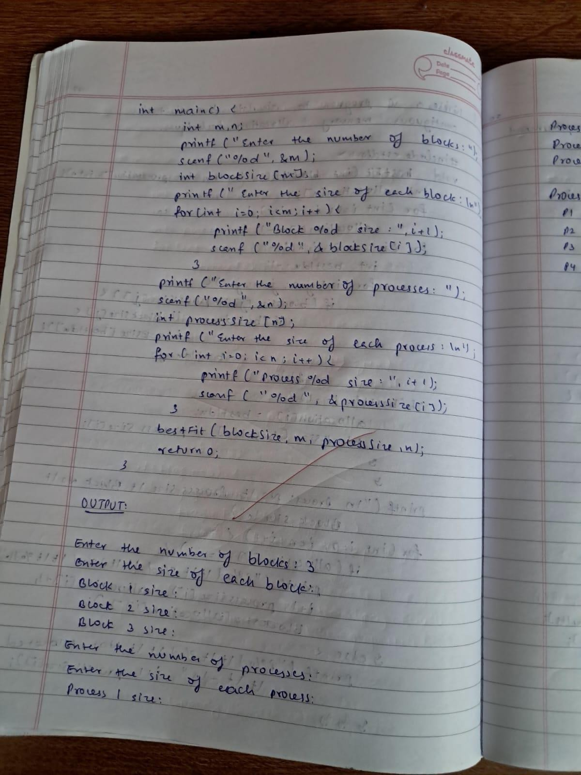

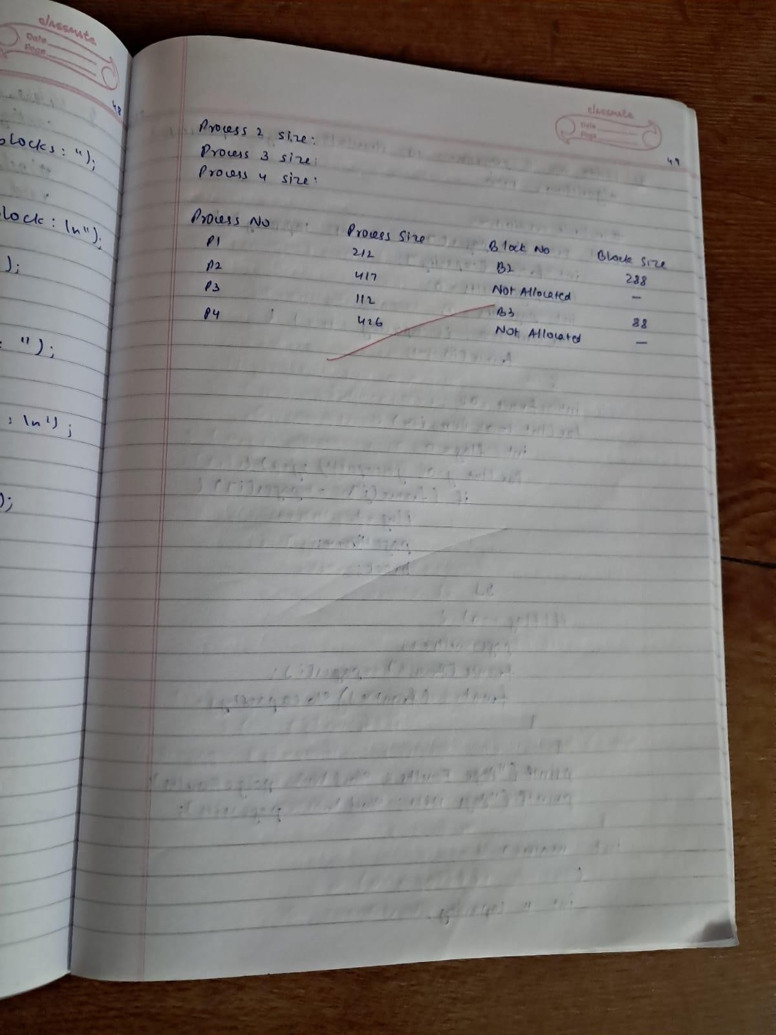

**Write a C program to simulate page replacement algorithms.**

**a) FIFO CODE:**

#include <stdio.h>

void FIFO(int pages[], int n, int capacity) { int frame[capacity];

int pageFaults = 0; int pageHits = 0;

for (int i = 0; i < capacity; i++) { frame[i] = -1;

}

int front = 0;

for (int i = 0; i < n; i++) { int flag = 0;

for (int j = 0; j < capacity; j++) { if (frame[j] == pages[i]) {

flag = 1; pageHits++; break;

}

}

if (flag == 0) { pageFaults++; frame[front] = pages[i];

front = (front + 1) % capacity;

}

}

printf("Page Faults: %d\n", pageFaults); printf("Page Hits: %d\n", pageHits);

}

int main() {

int n, capacity;

printf("Enter number of pages: "); scanf("%d", &n);

int pages[n]; printf("Enter pages:\n"); for (int i = 0; i < n; i++) {

scanf("%d", &pages[i]);

}

printf("Enter frame capacity: "); scanf("%d", &capacity);

FIFO(pages, n, capacity);

return 0;

}

# OUTPUT:

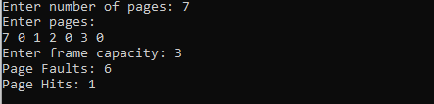

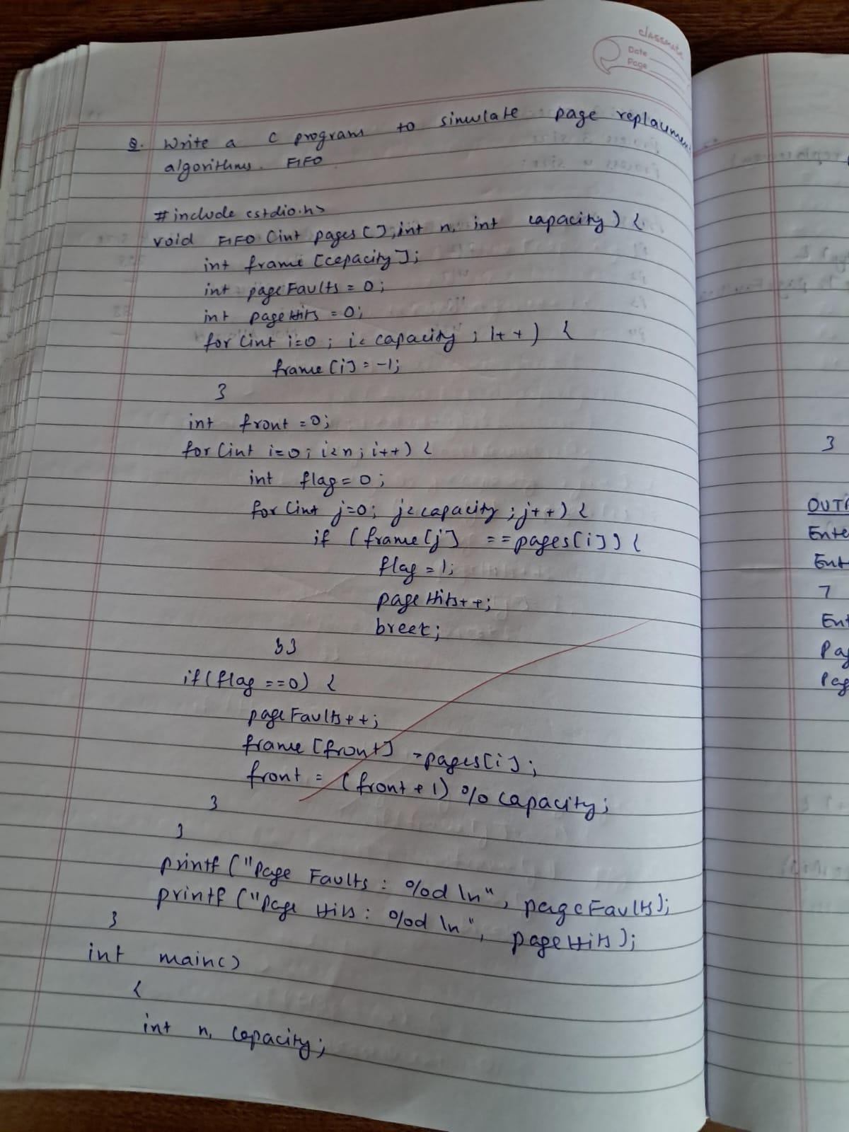

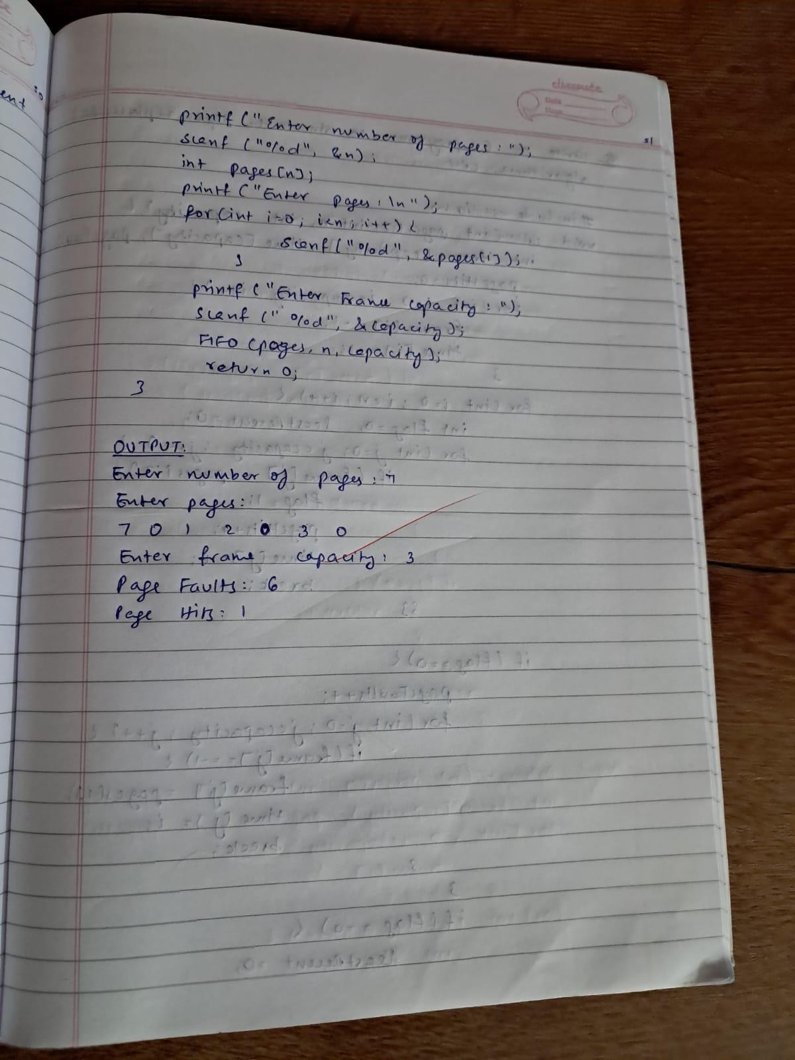

**Write a C program to simulate page replacement algorithms. LRU**

# CODE:

#include <stdio.h>

void LRU(int pages[], int n, int capacity) {

int frame[capacity], time[capacity], pageFaults = 0, pageHits = 0;

for (int i = 0; i < capacity; i++) { frame[i] = -1;

time[i] = -1;

}

for (int i = 0; i < n; i++) {

int flag = 0, leastRecent = 0;

for (int j = 0; j < capacity; j++) { if (frame[j] == pages[i]) {

flag = 1; pageHits++; time[j] = i; break;

}

}

if (flag == 0) { pageFaults++;

for (int j = 0; j < capacity; j++) { if (frame[j] == -1) {

frame[j] = pages[i]; time[j] = i;

break;

}

}

if (flag == 0) { leastRecent = 0;

for (int j = 1; j < capacity; j++) {

if (time[j] < time[leastRecent]) { leastRecent = j;

}

}

frame[leastRecent] = pages[i]; time[leastRecent] = i;

}

}

}

printf("Page Faults: %d\n", pageFaults); printf("Page Hits: %d\n", pageHits);

}

int main() {

int n, capacity;

printf("Enter number of pages: "); scanf("%d", &n);

int pages[n]; printf("Enter pages:\n"); for (int i = 0; i < n; i++) {

scanf("%d", &pages[i]);

}

printf("Enter frame capacity: "); scanf("%d", &capacity);

LRU(pages, n, capacity);

return 0;

}

# OUTPUT:

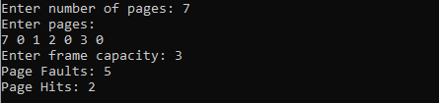

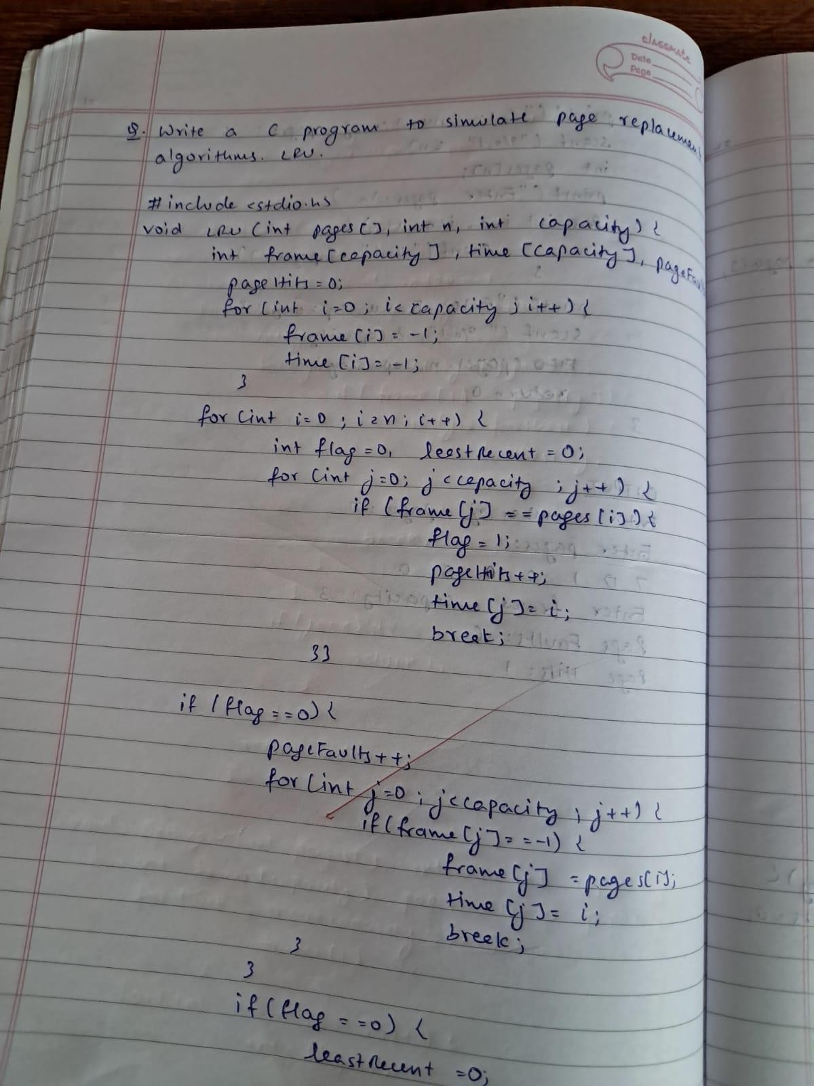

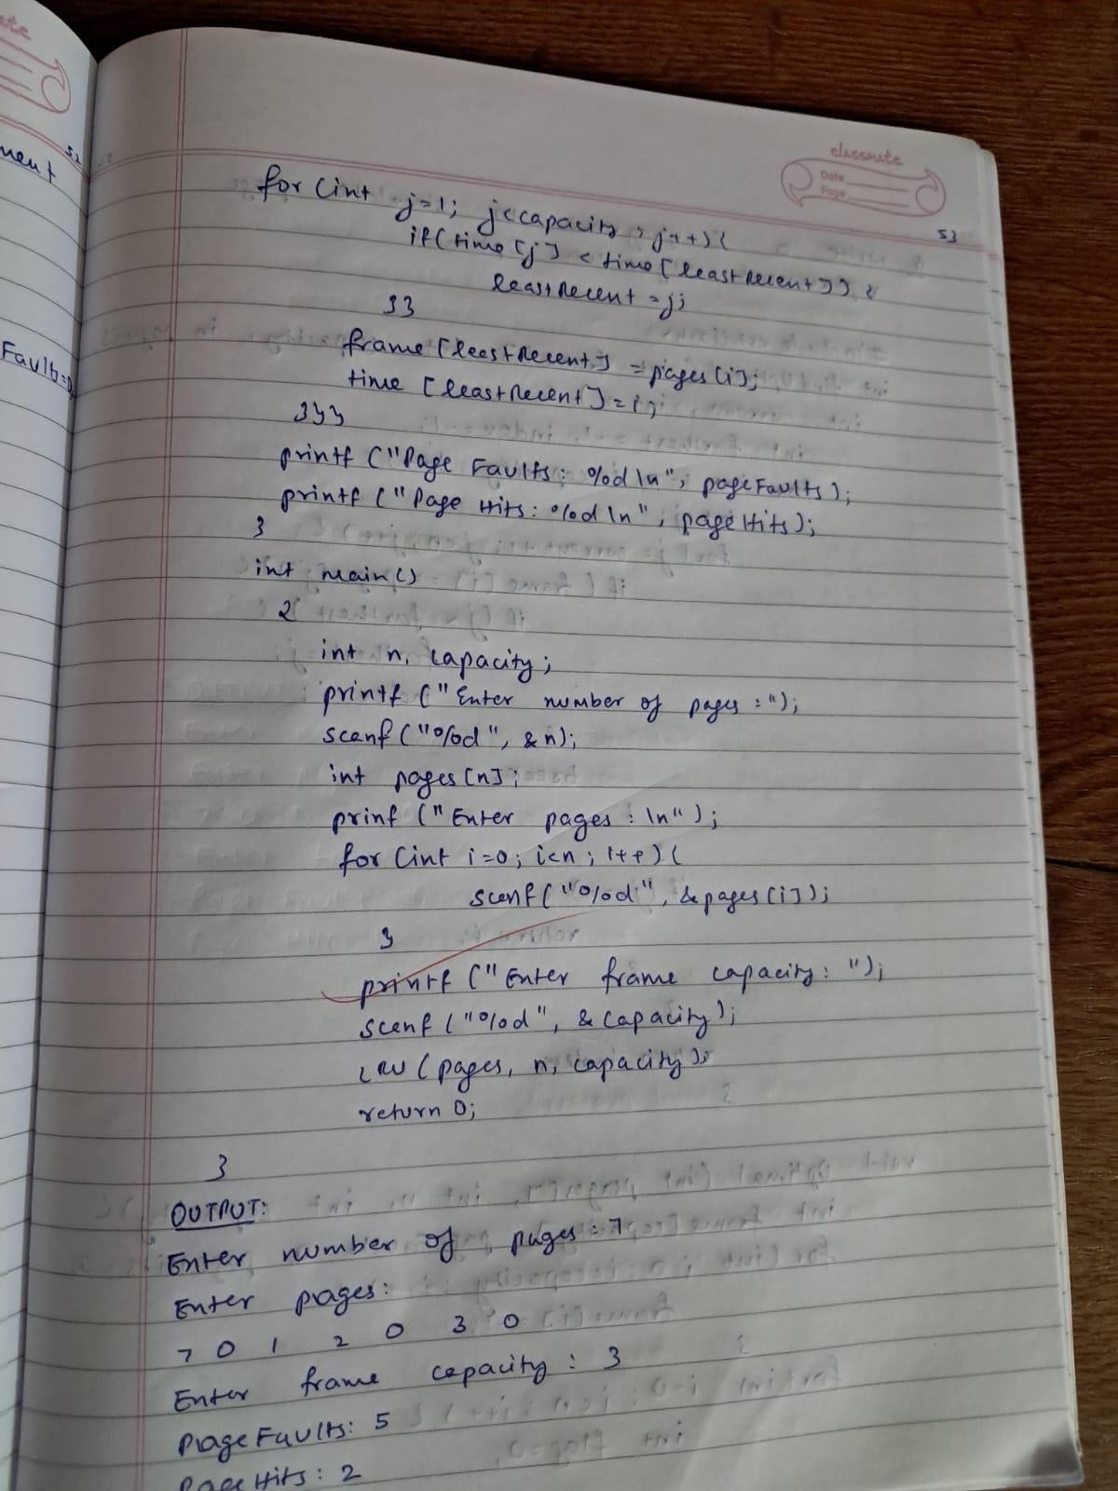

**Write a C program to simulate page replacement algorithms. Optimal**

# CODE:

#include <stdio.h>

int findOptimal(int frame[], int capacity, int pages[], int current, int n) { int farthest = -1, index = -1;

for (int i = 0; i < capacity; i++) { int j;

for (j = current + 1; j < n; j++) { if (frame[i] == pages[j]) {

if (j > farthest) { farthest = j; index = i;

}

break;

}

}

if (j == n) { return i;

}

}

return index;

}

void Optimal(int pages[], int n, int capacity) {

int frame[capacity], pageFaults = 0, pageHits = 0;

for (int i = 0; i < capacity; i++) { frame[i] = -1;

}

for (int i = 0; i < n; i++) { int flag = 0;

for (int j = 0; j < capacity; j++) { if (frame[j] == pages[i]) {

flag = 1; pageHits++; break;

}

}

if (flag == 0) { pageFaults++;

int replaceIndex = findOptimal(frame, capacity, pages, i, n); frame[replaceIndex] = pages[i];

}

}

printf("Page Faults: %d\n", pageFaults); printf("Page Hits: %d\n", pageHits);

}

int main() {

int n, capacity;

printf("Enter number of pages: "); scanf("%d", &n);

int pages[n];

printf("Enter pages:\n"); for (int i = 0; i < n; i++) {

scanf("%d", &pages[i]);

}

printf("Enter frame capacity: "); scanf("%d", &capacity);

Optimal(pages, n, capacity);

return 0;

}

**OUTPUT:**



